BLUE AMMONIA
Platform & Infrastructure Prospectus

Homepage and Platform Entry Point
The homepage functions as the executive entry point into the Blue Ammonia platform. It introduces the brand, the mission, the portal navigation, and the primary operating functions available to visitors and future subscribers.

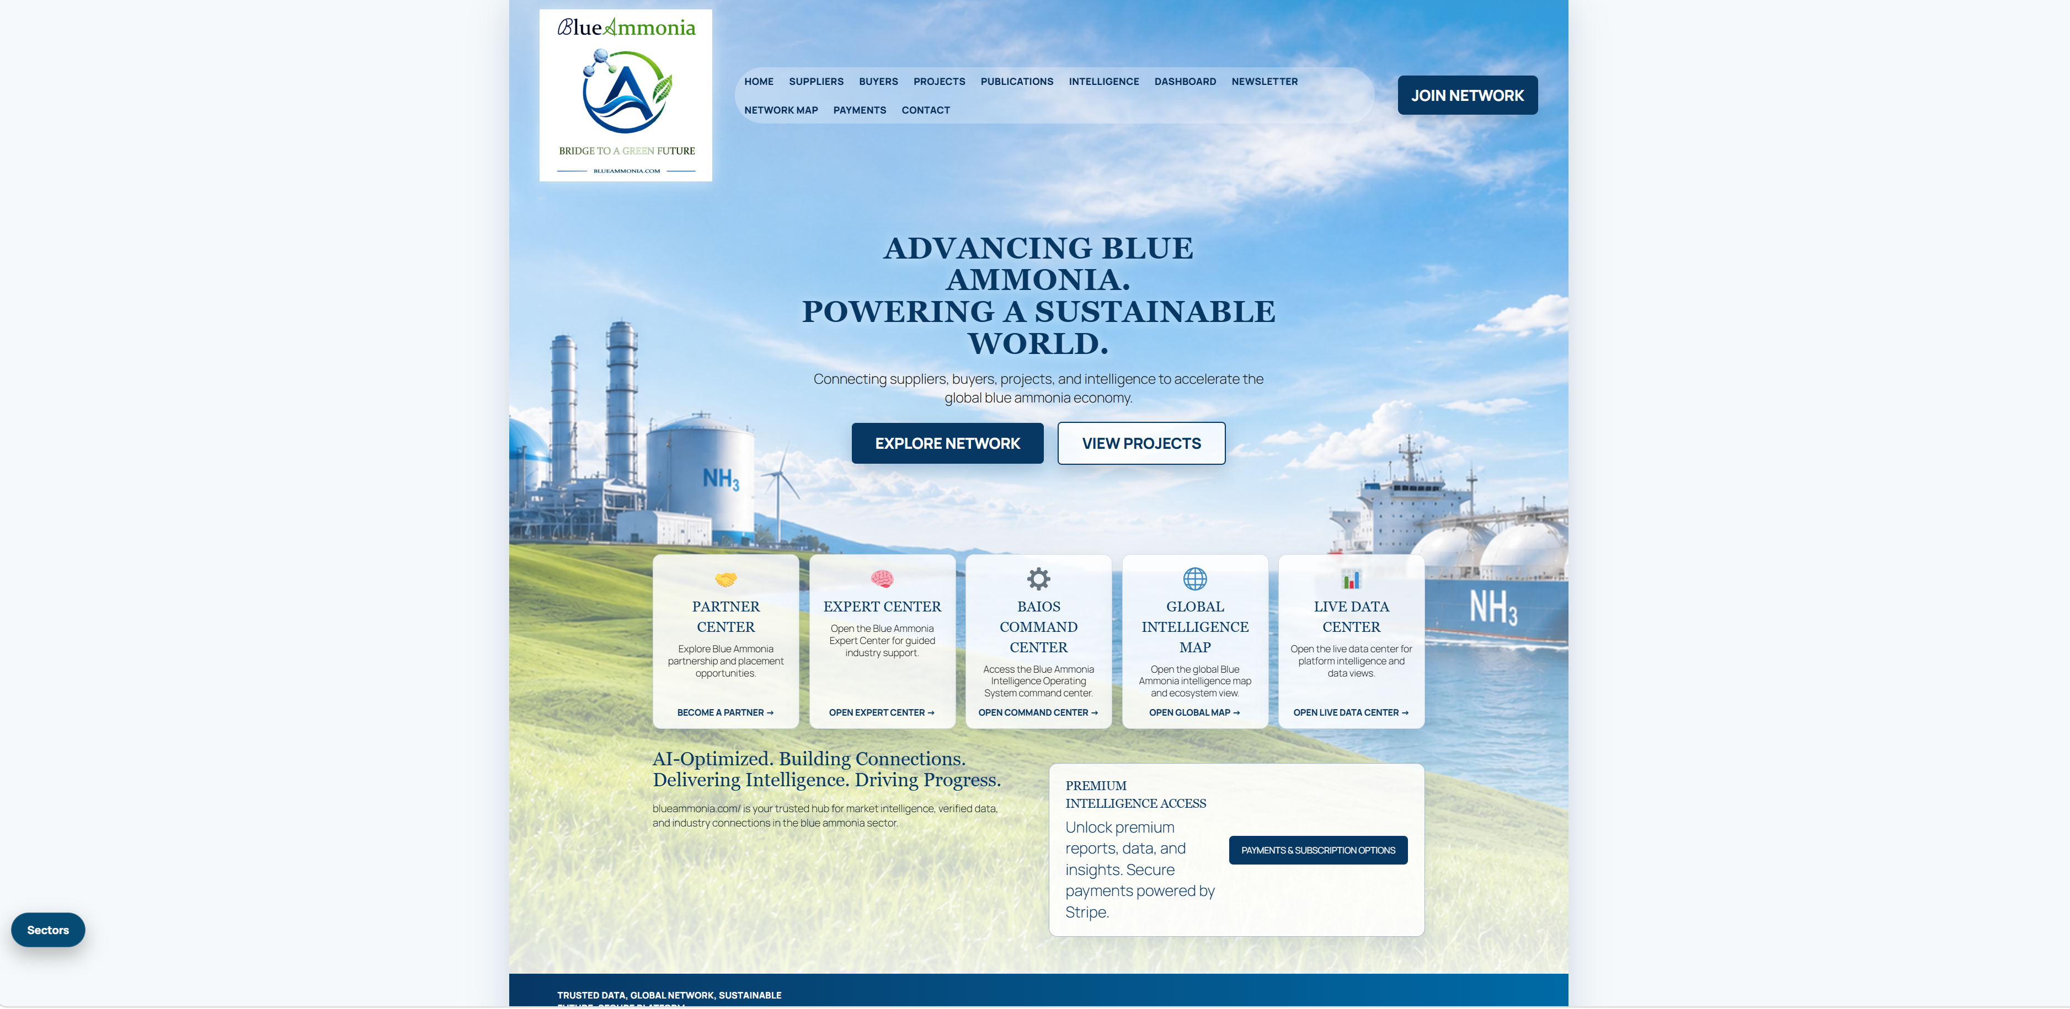
Homepage upper section.
Advancing Blue Ammonia. Powering a Sustainable World.
Prepared for industry outreach, strategic partnerships, sponsors, and commercial participants.

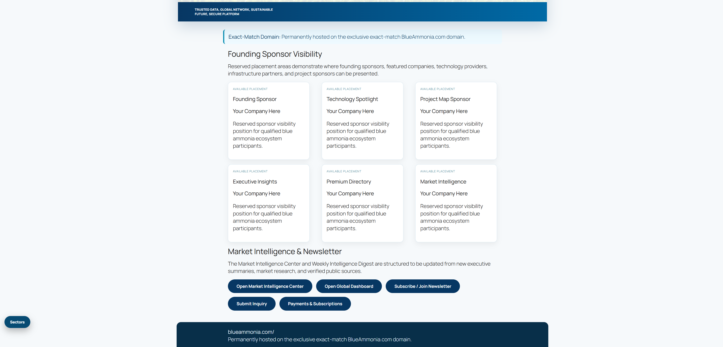
Homepage lower section.

Letter from the Founder
Blue Ammonia was founded to support the continued growth of the global blue ammonia industry through independent market intelligence, commercial networking, industry collaboration, and practical AI-assisted information services.
Drawing upon many years of experience supporting industrial and infrastructure projects, together with an Architecture degree from Columbia University emphasizing sustainable infrastructure, renewable energy, and responsible development, I established Blue Ammonia to help connect the organizations and professionals helping shape this rapidly evolving global industry.
The blue ammonia economy represents the convergence of energy production, transportation, infrastructure, carbon management, agriculture, shipping, industrial manufacturing, and international trade. Blue Ammonia seeks to provide a common platform where these diverse participants can discover opportunities, share information, develop partnerships, and improve market transparency.
Blue Ammonia was intentionally designed as an independent industry platform. Our goal is not to replace existing organizations or associations, but to complement their efforts by providing practical commercial networking, accessible intelligence resources, sector organization, and emerging AI capabilities.
Relationships create opportunities. Information creates value. Trust creates markets. Intelligence should become infrastructure.
Stevie Alston
Founder & CEO
Blue Ammonia Holdings LLC

Executive Overview
BlueAmmonia.com is an independent industry platform supporting the global blue ammonia ecosystem through market intelligence, commercial networking, sector directories, RFQ capabilities, publications, and AI-assisted industry exploration.
The portal is designed for industry participants who need clearer visibility into emerging projects, buyers, suppliers, commercial opportunities, technology providers, ports, storage providers, EPC contractors, financial participants, certification organizations, and related market actors.

Primary Platform Functions
- Independent market intelligence
- Commercial networking and industry visibility
- Buyer and supplier directories
- Sector-specific RFQ and inquiry pathways
- AI-assisted Expert Center
- BAIOS Command Center and operational dashboards
- Commercial model for sponsors, featured listings, and premium intelligence
- Network Map showing portal relationships and workflows

Independent Platform Statement
BlueAmmonia.com was established as an independent industry platform dedicated to supporting the continued growth of the global blue ammonia ecosystem through market intelligence, commercial networking, industry collaboration, and practical AI-assisted information services. Blue Ammonia seeks to complement - not replace - the valuable work already being performed by producers, technology providers, ports, governments, industry associations, engineering firms, and other stakeholders throughout the global ammonia value chain.

Portal Navigation Guide
The top navigation and homepage cards create two complementary pathways. The top navigation provides traditional portal navigation. The five large homepage cards present the platform's higher-value functions: Partner Center, Expert Center, BAIOS Command Center, Global Intelligence Map, and Live Data Center.
Portal Area | Purpose
Home | Primary platform entry point and public landing page
Suppliers | Supplier and service-provider discovery
Buyers | Buyer, offtaker and participant discovery
Projects | Blue ammonia project information and tracking
Publications | Reports, articles, and industry materials
Intelligence | Market intelligence center and related content
Sectors | 20-sector industry directory model
Expert Center | AI-assisted industry question and response center
BAIOS | Blue Ammonia Intelligence Operating System command center
Commercial Model | Sponsor, listing, intelligence and participation options

Buyers Directory
The Buyers Directory is designed to organize potential offtakers, utilities, traders, industrial consumers, maritime users, ports, governments, and other buyer-side stakeholders by sector. The current public model can provide navigation and sector context while preserving deeper curated data for future subscribers.

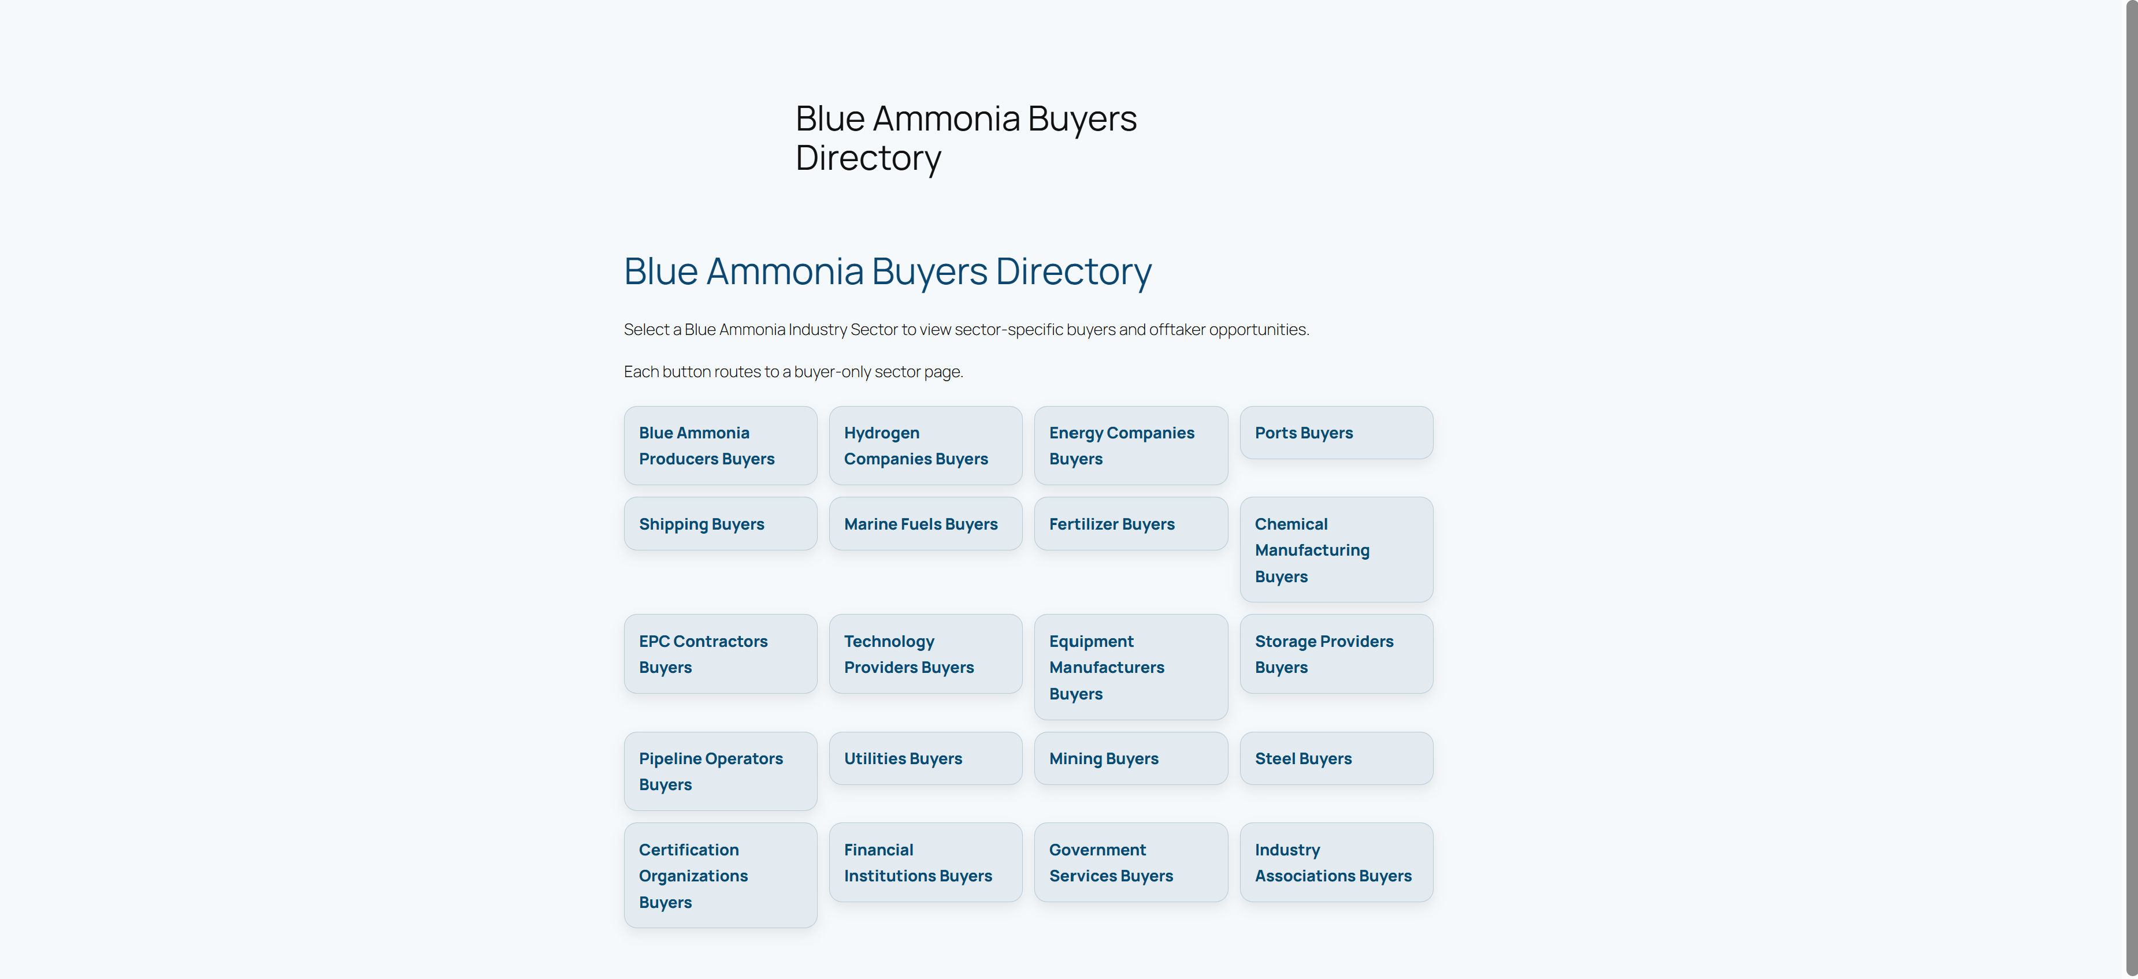
Buyers Directory

Suppliers Directory
The Suppliers Directory organizes producers, technology providers, equipment manufacturers, EPC firms, storage providers, industrial gas companies, certification organizations, and other supplier-side participants. The model supports visibility, commercial discovery, and future premium listing opportunities.

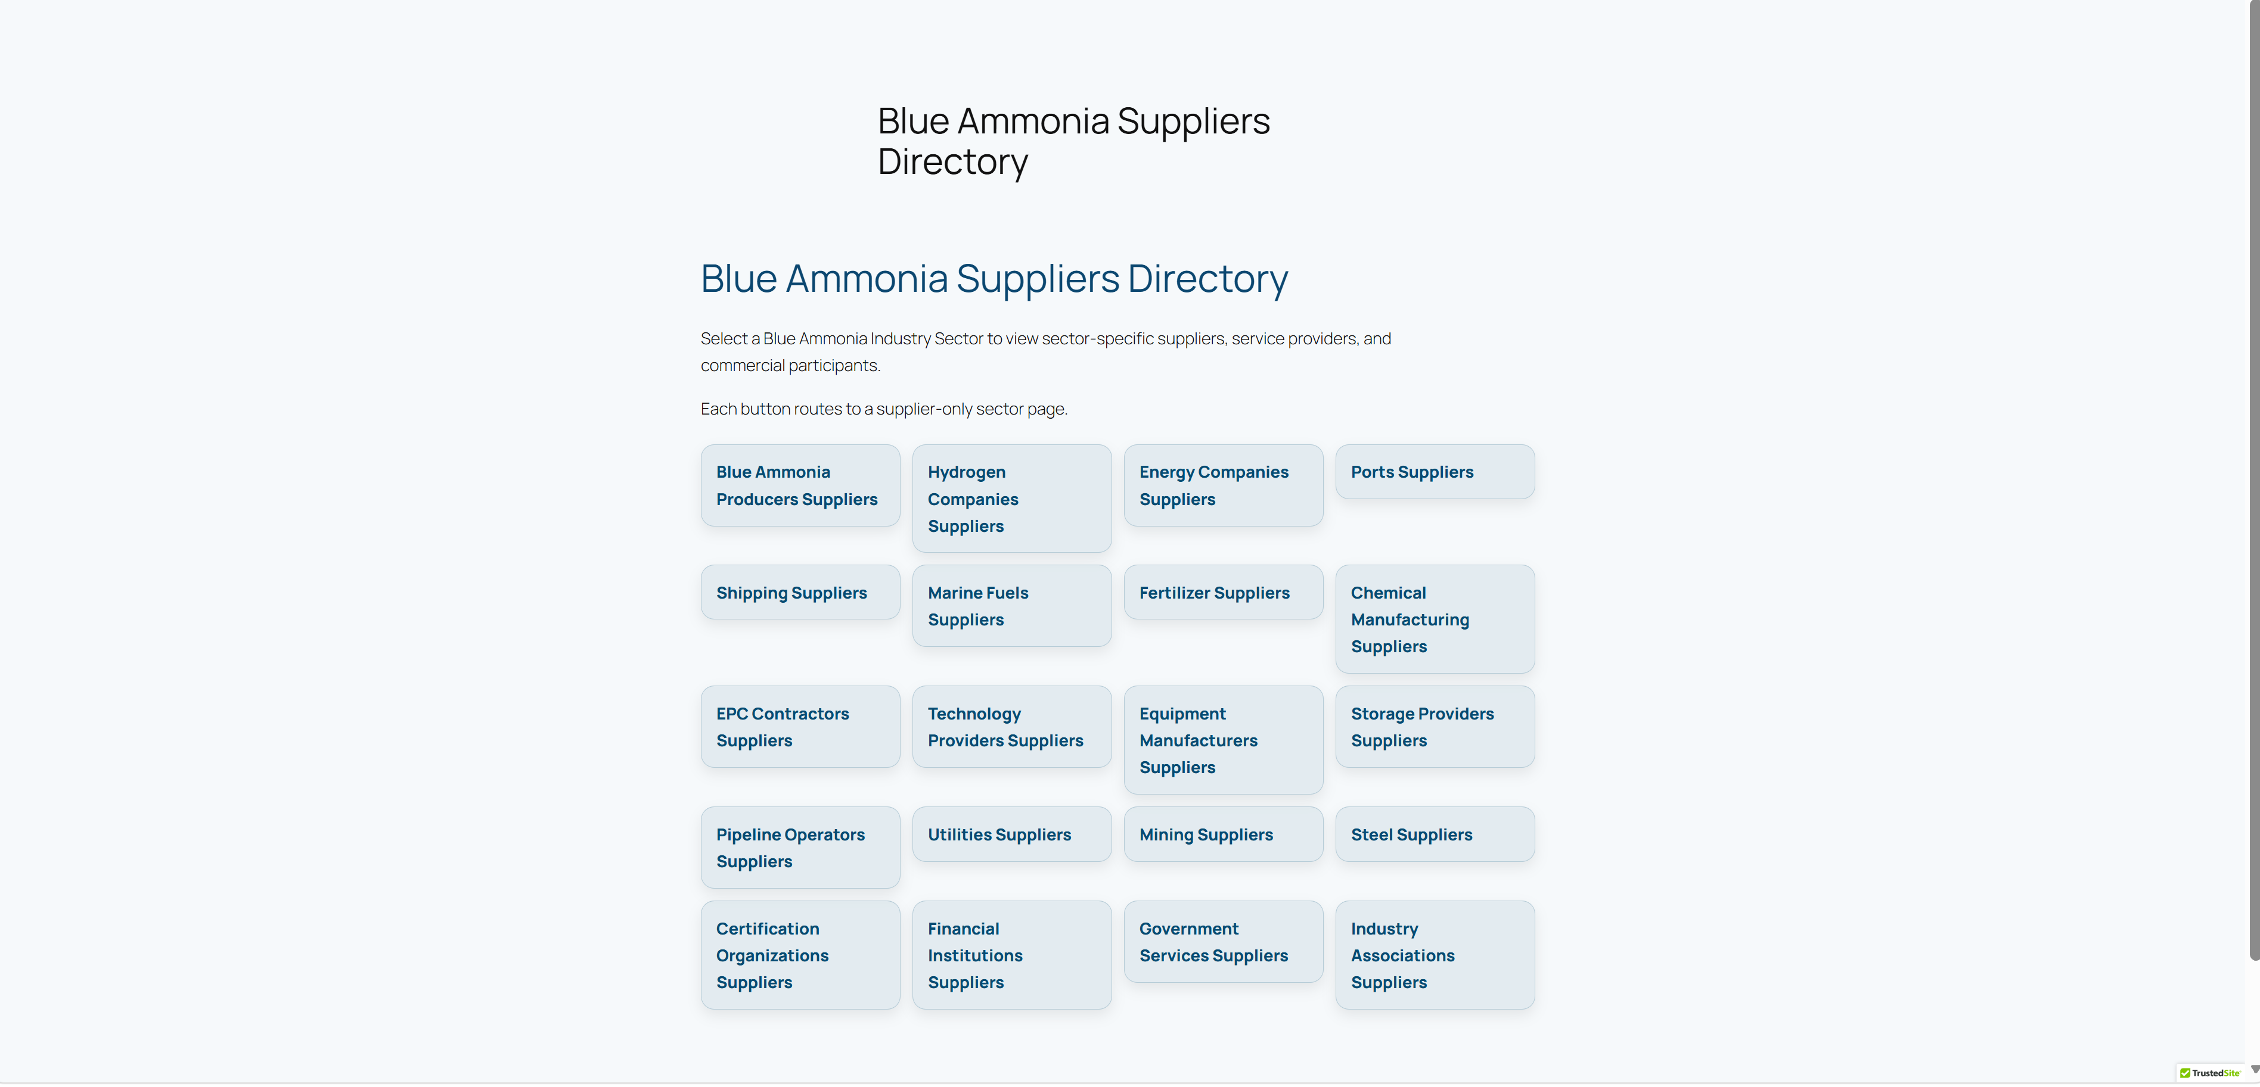
Suppliers Directory

Industry Sector Ecosystem
Blue Ammonia uses a 20-sector model to organize the ecosystem into practical commercial segments. Each sector can support buyer pages, supplier pages, and RFQ/inquiry workflows while sharing common platform-wide resources such as intelligence, publications, BAIOS, and the Expert Center.

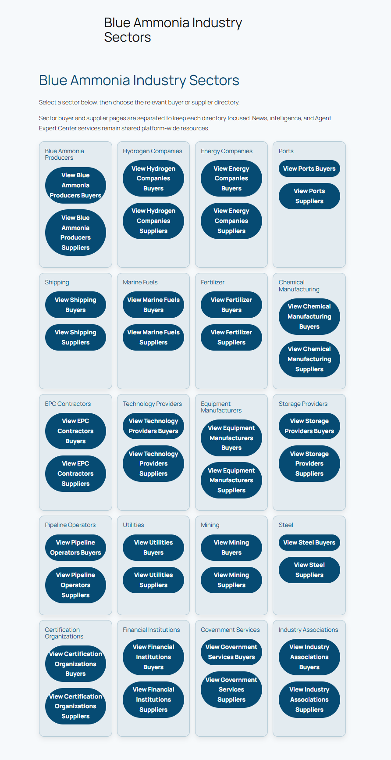
Sectors include
- Blue Ammonia Producers
- Hydrogen Companies
- Energy Companies
- Ports
- Shipping
- Marine Fuels
- Fertilizer
- Chemical Manufacturing
- EPC Contractors
- Technology Providers
- Equipment Manufacturers
- Storage Providers
- Pipeline Operators
- Utilities
- Mining
- Steel
- Certification Organizations
- Financial Institutions
- Government Services
- Industry Associations

Network Map and Portal Ecosystem
The Portal Network Map shows how users can move through the platform: from the homepage into industry categories, directory resources, intelligence services, newsletters, commercial participation and RFQ pathways. It gives visitors a structured view of Blue Ammonia as a connected ecosystem rather than a static website.

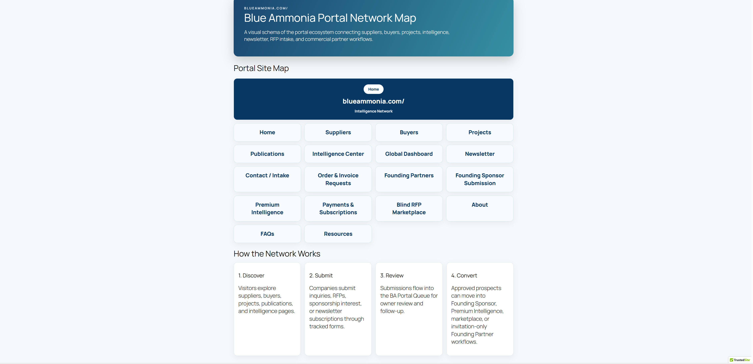
Portal Network Map

Commercial Model
The Commercial Model page explains how companies can participate through visibility, listings, sponsorship, premium intelligence, RFQs, and future commercial-networking pathways. The model is designed to generate value without forcing premature sales conversations during initial outreach.

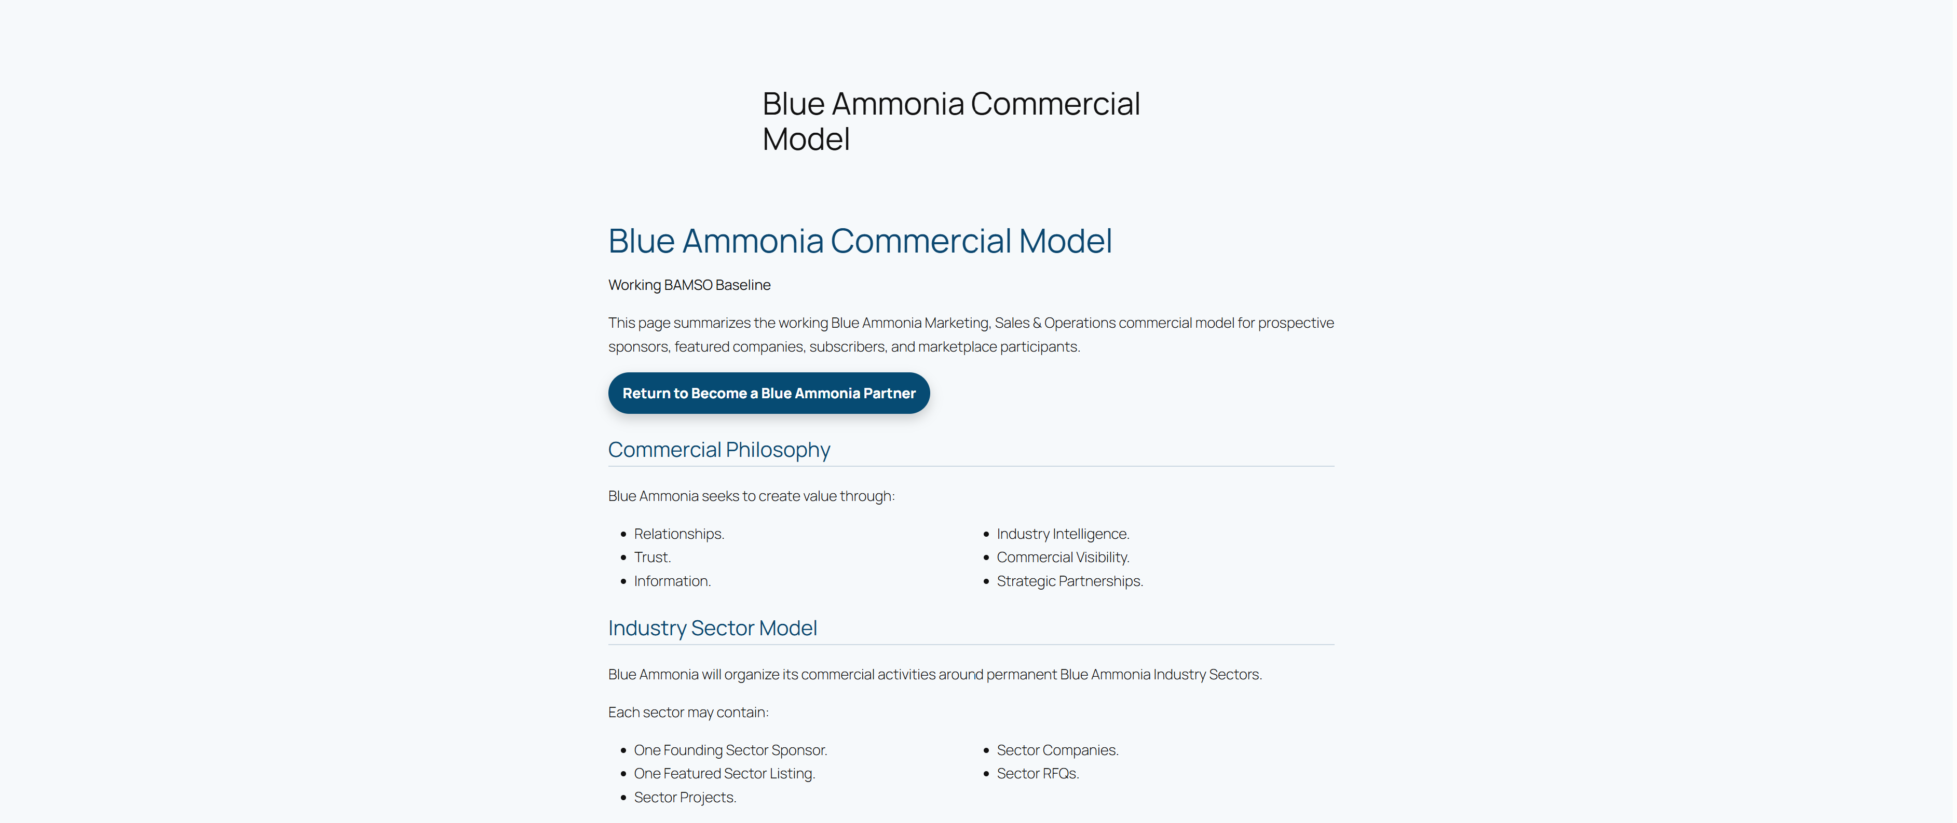
Commercial Model - participation framework
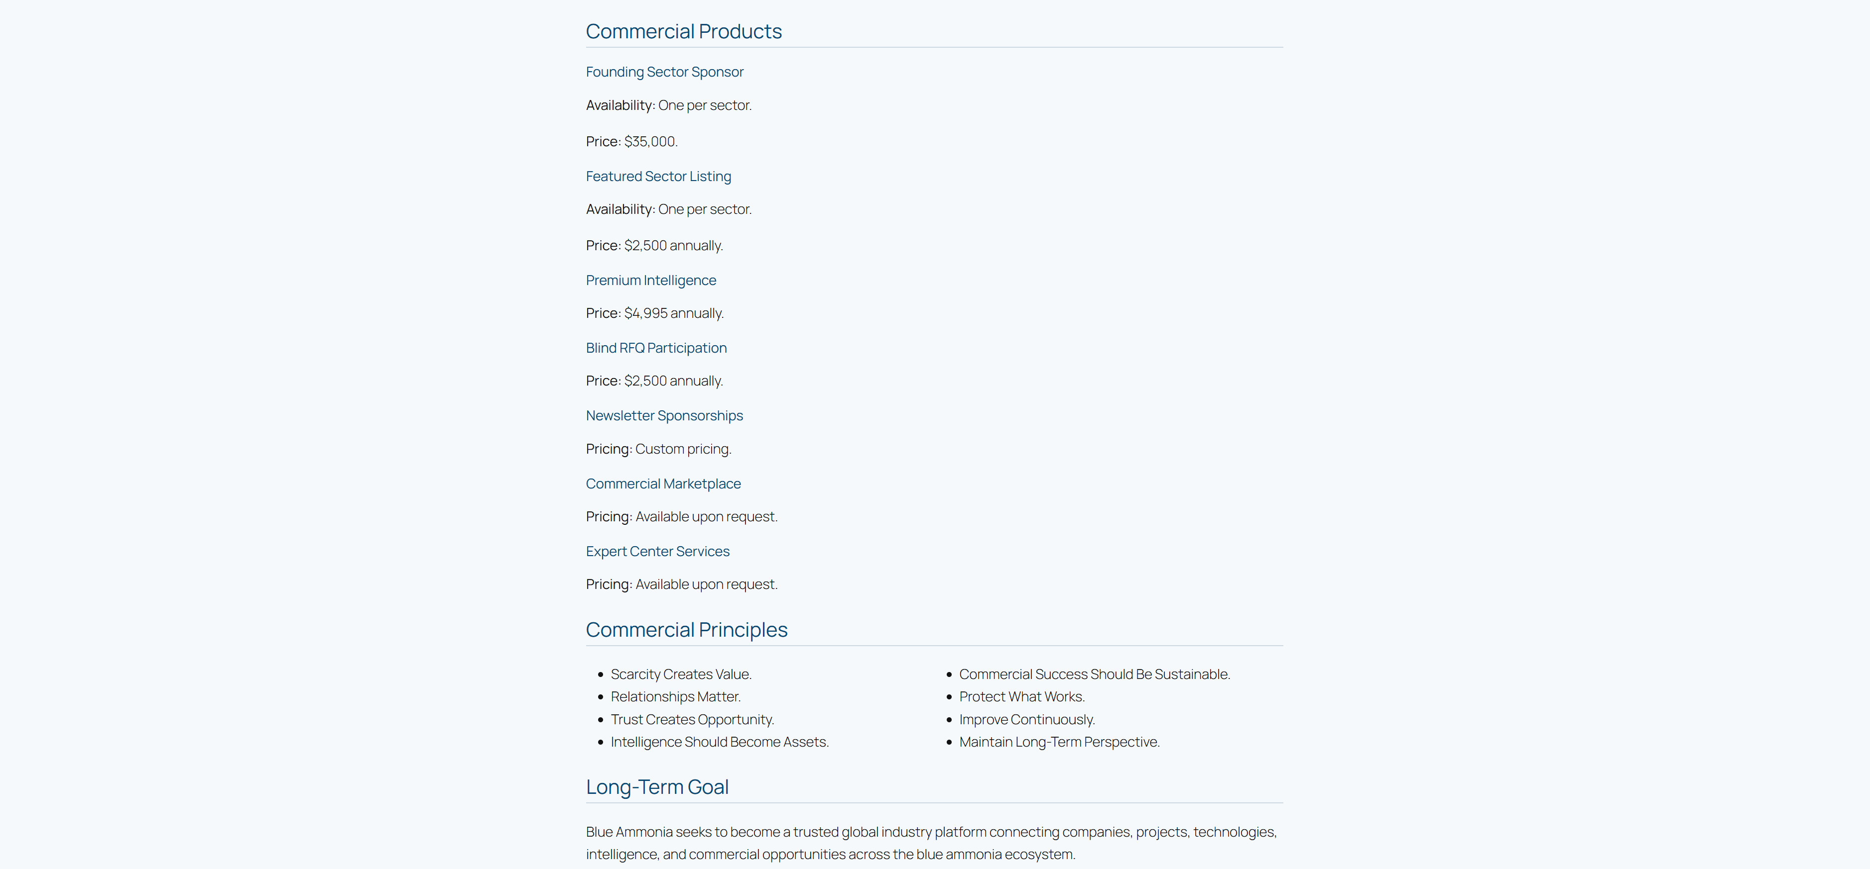

Commercial Model - sector-based opportunities

BAIOS Command Center
BAIOS - the Blue Ammonia Intelligence Operating System - represents the operational intelligence layer of the platform. It is intended to support project tracking, commercial intelligence, market monitoring, content production, dashboarding, and future subscriber-facing intelligence services.

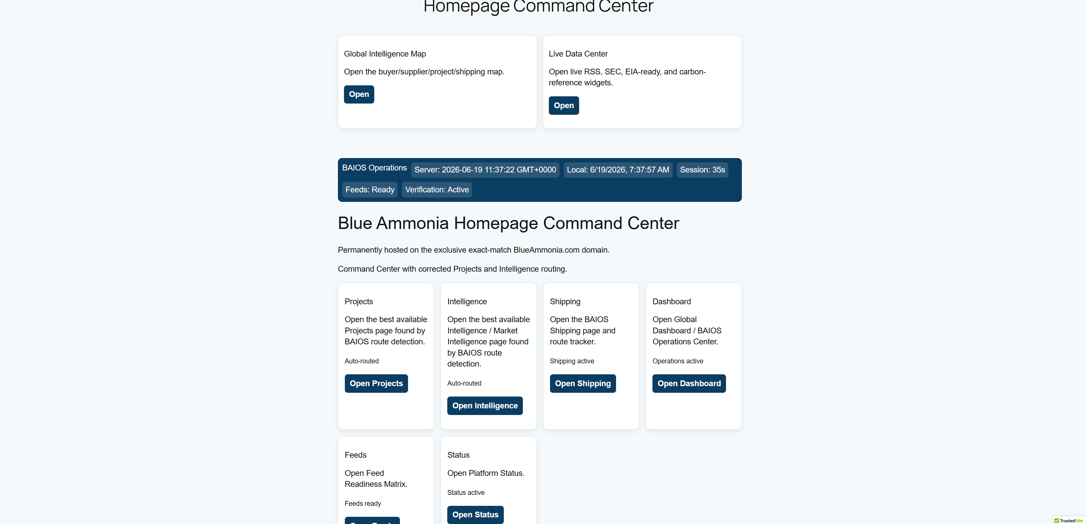

BAIOS Command Center - operational overview
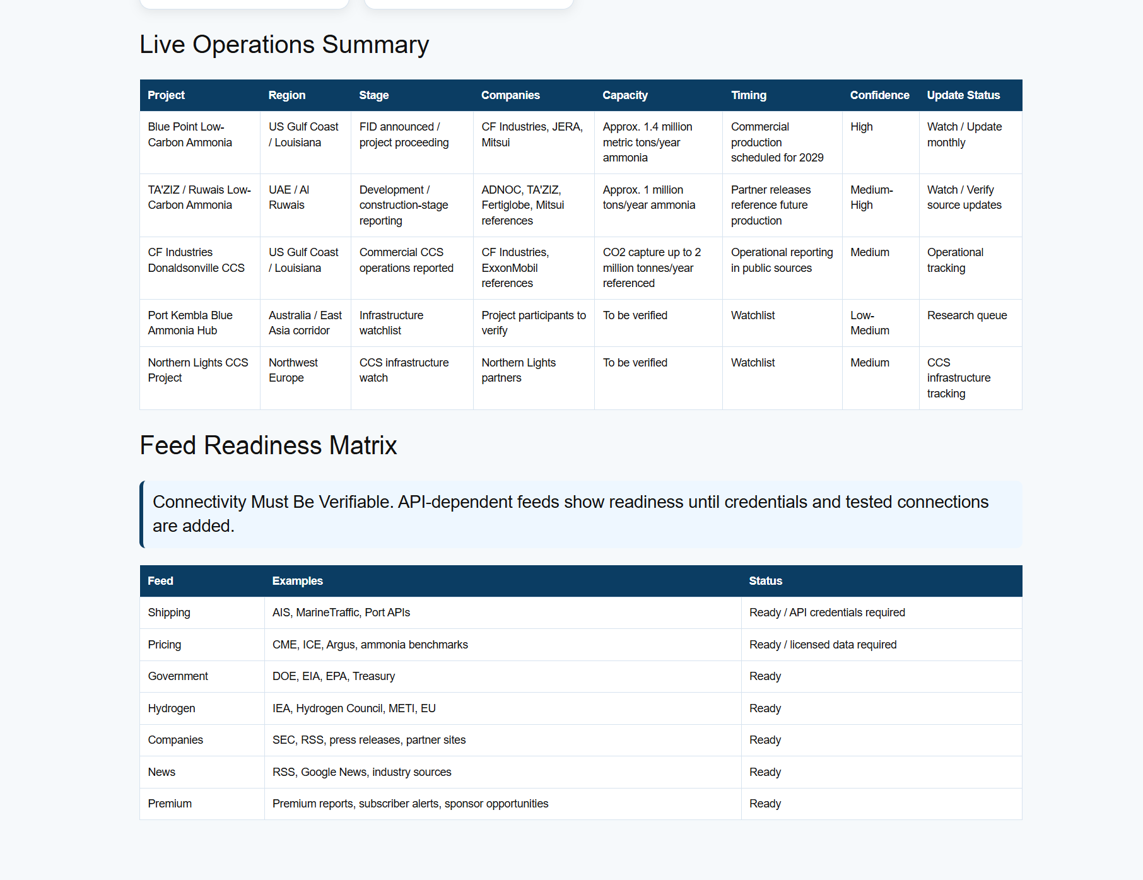

Expert Center
The Expert Center introduces AI-assisted industry exploration. It is intended to support executive briefings, commercial intelligence, project analysis, subscriber support, newsletter generation, reputation mapping, and public assistance across the Blue Ammonia ecosystem.

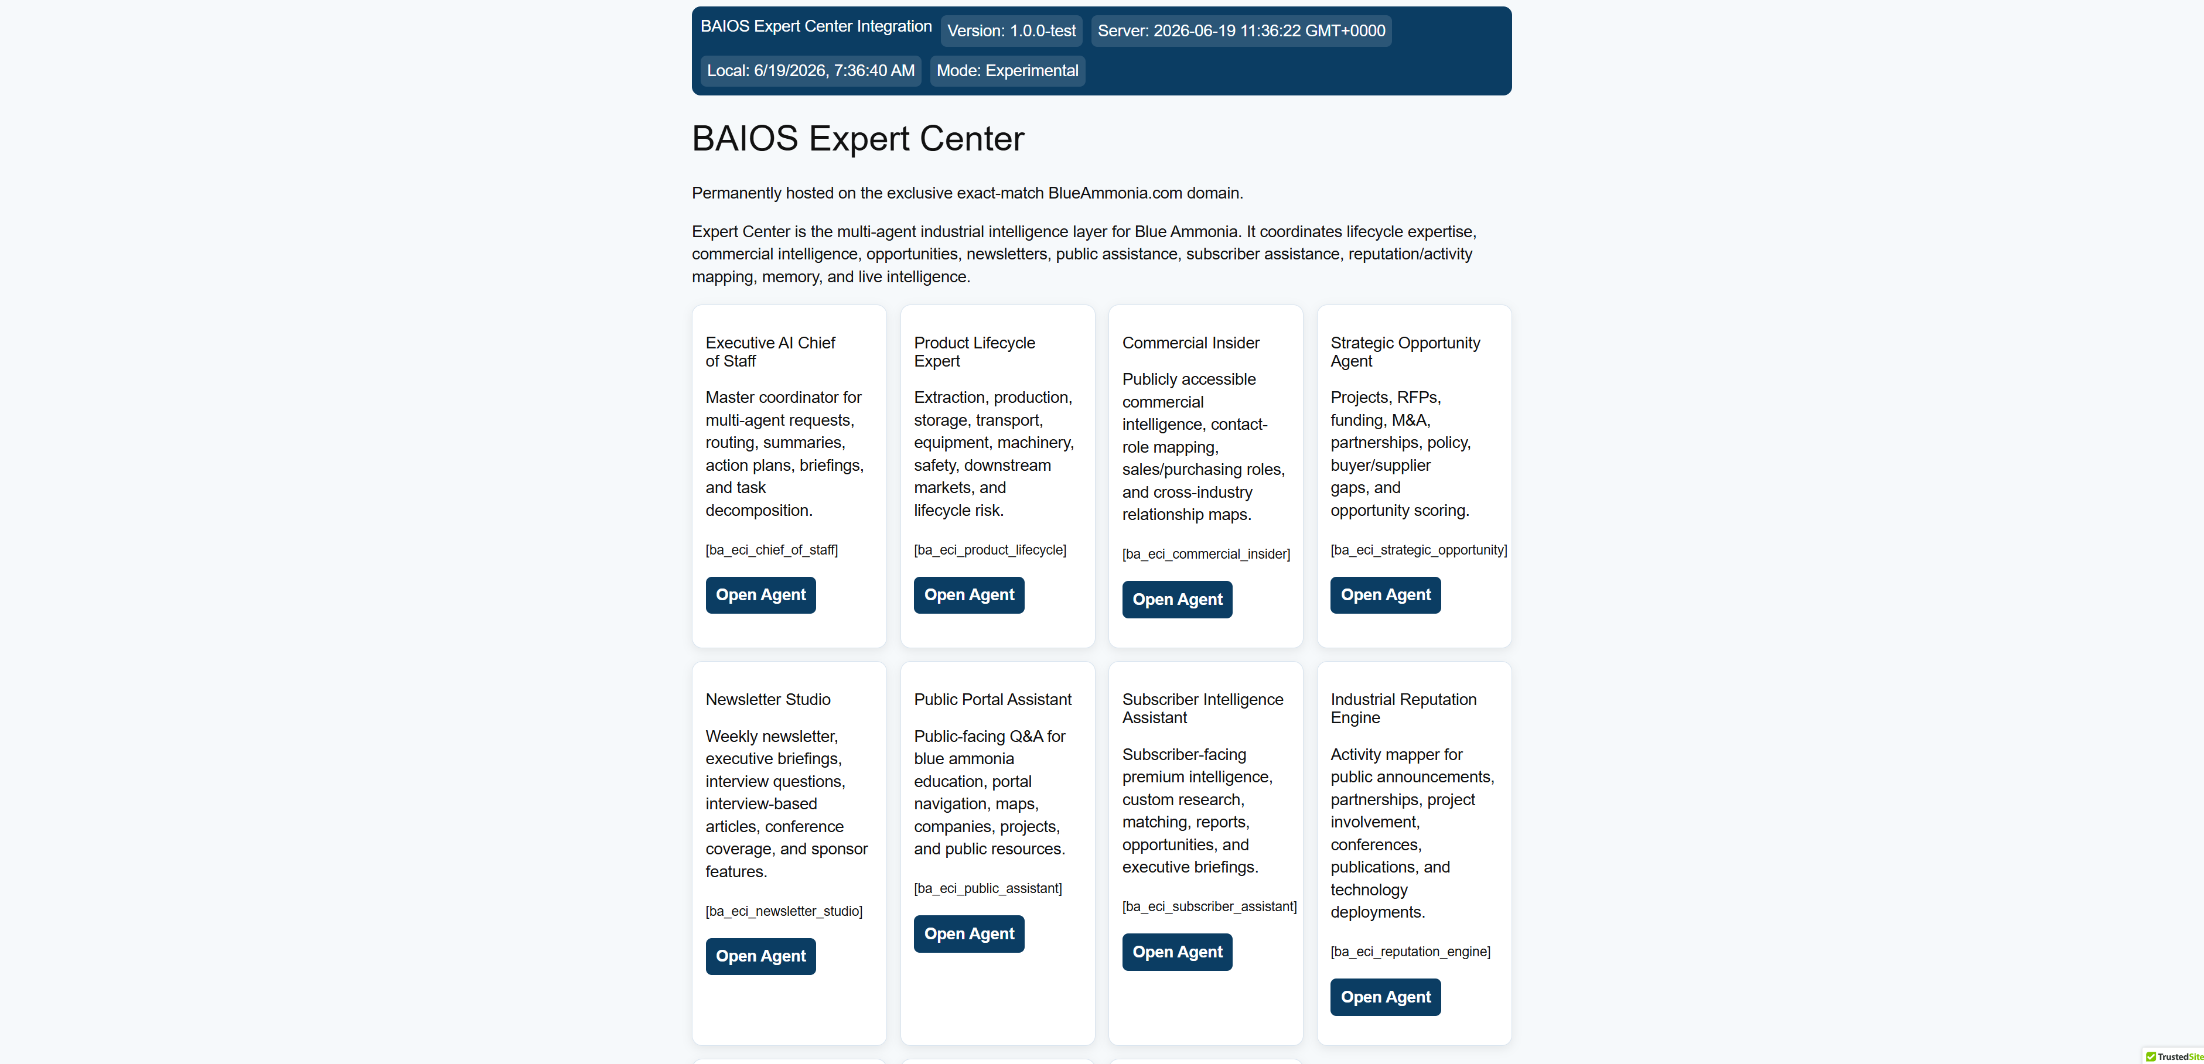

Expert Center with agent panels

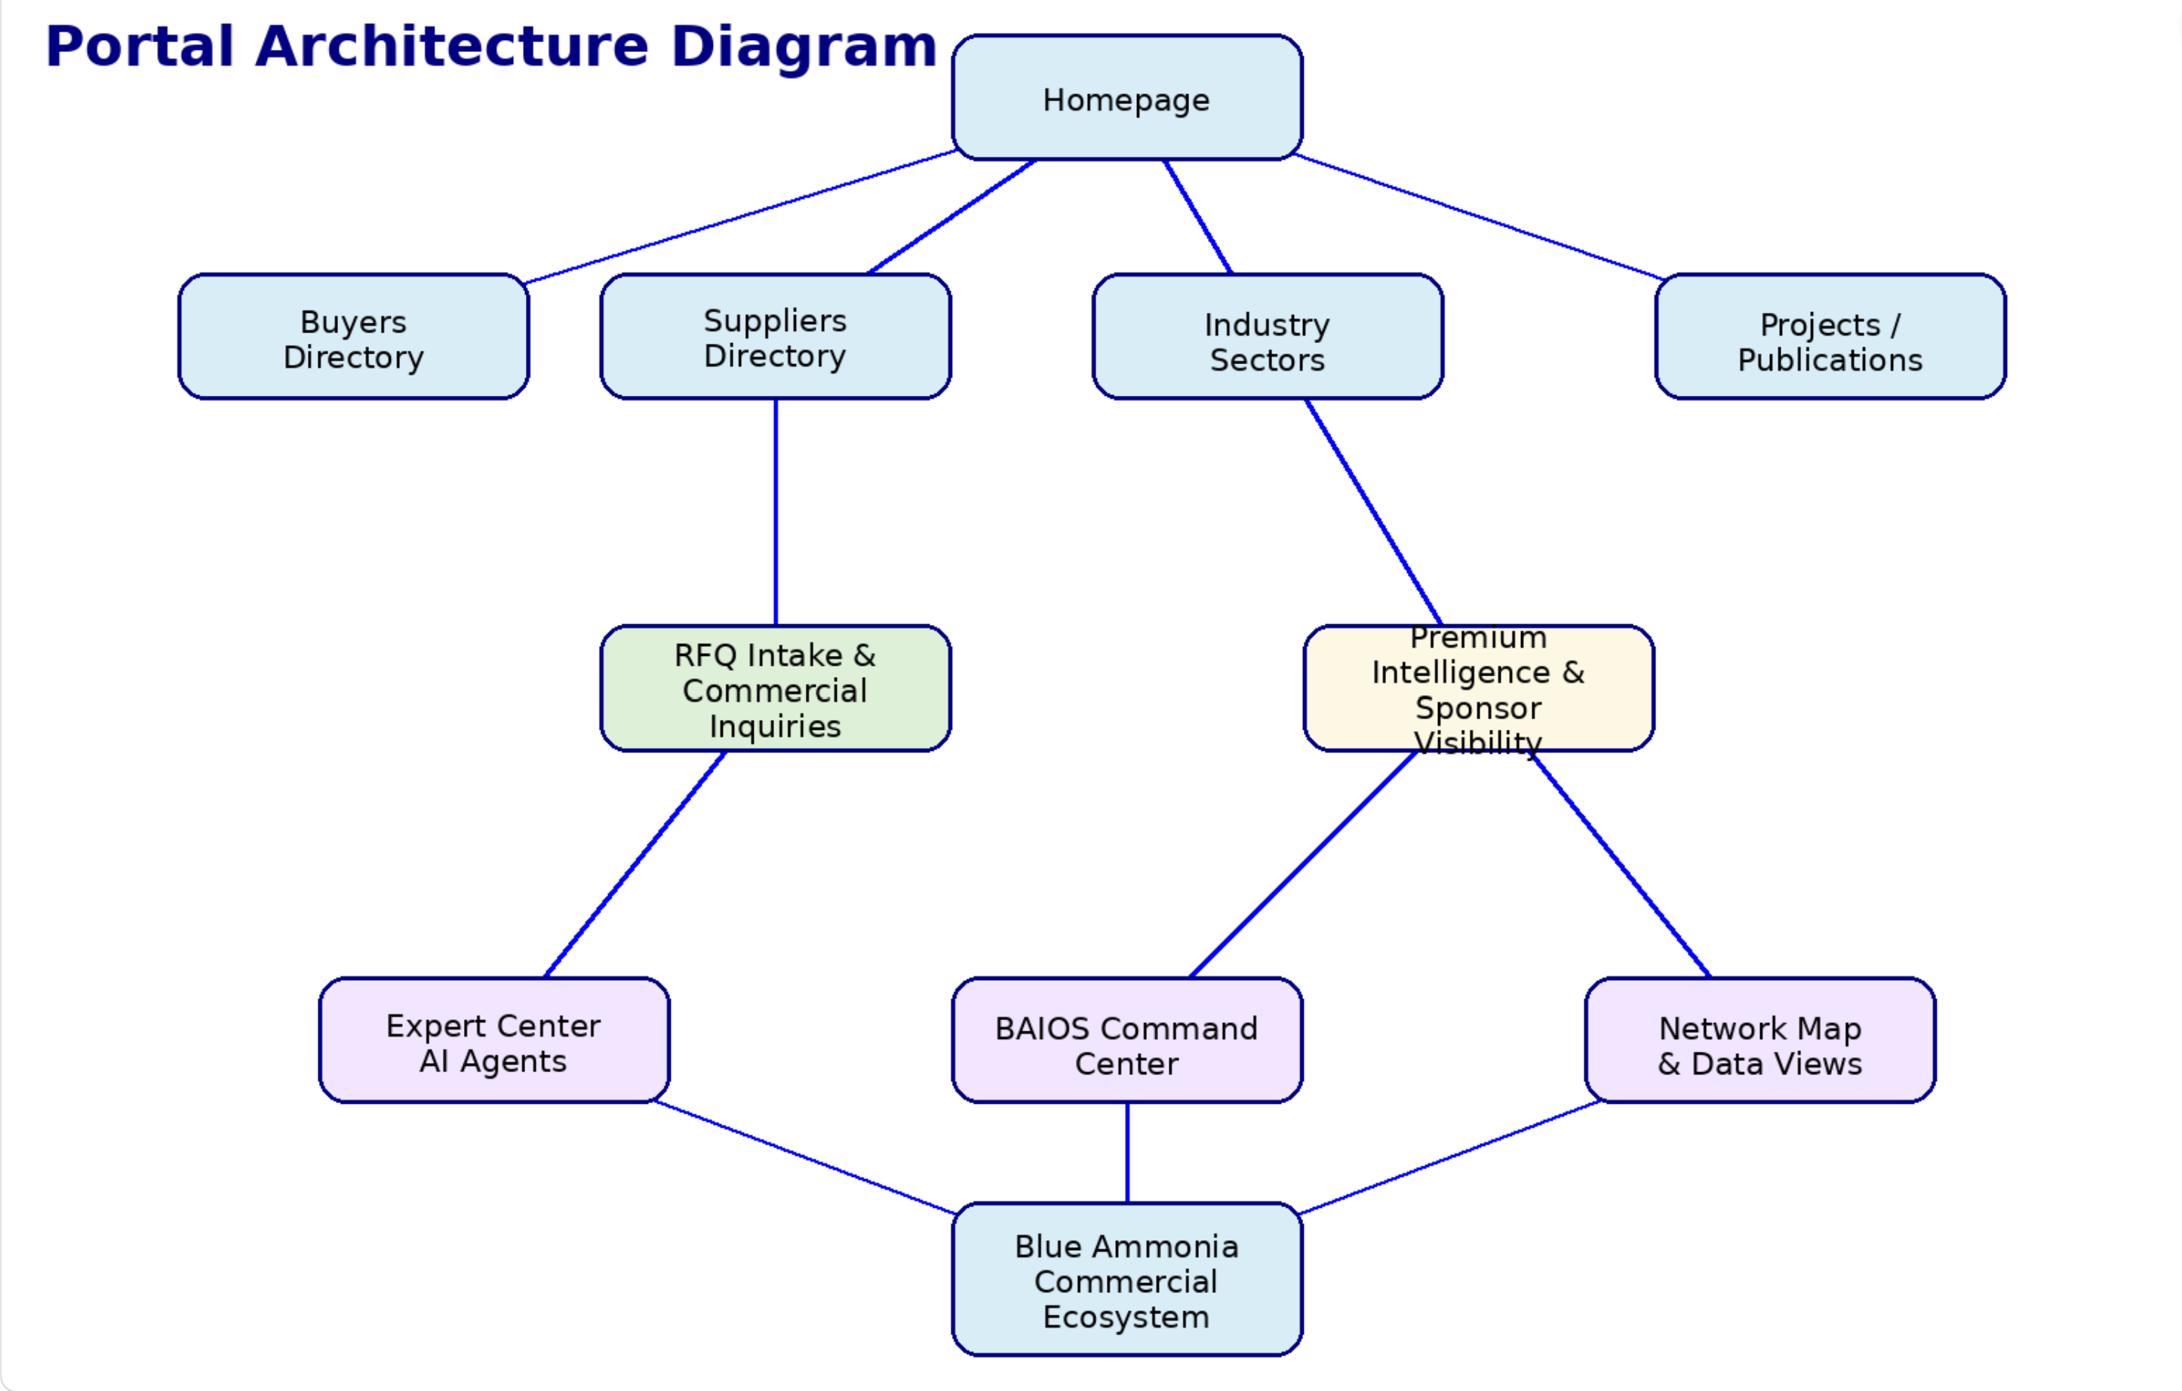
This architecture emphasizes a layered platform model: public discovery, sector organization, commercial inquiry, intelligence access, AI-assisted support, and sponsorship or subscriber pathways.

Commercial User Journey
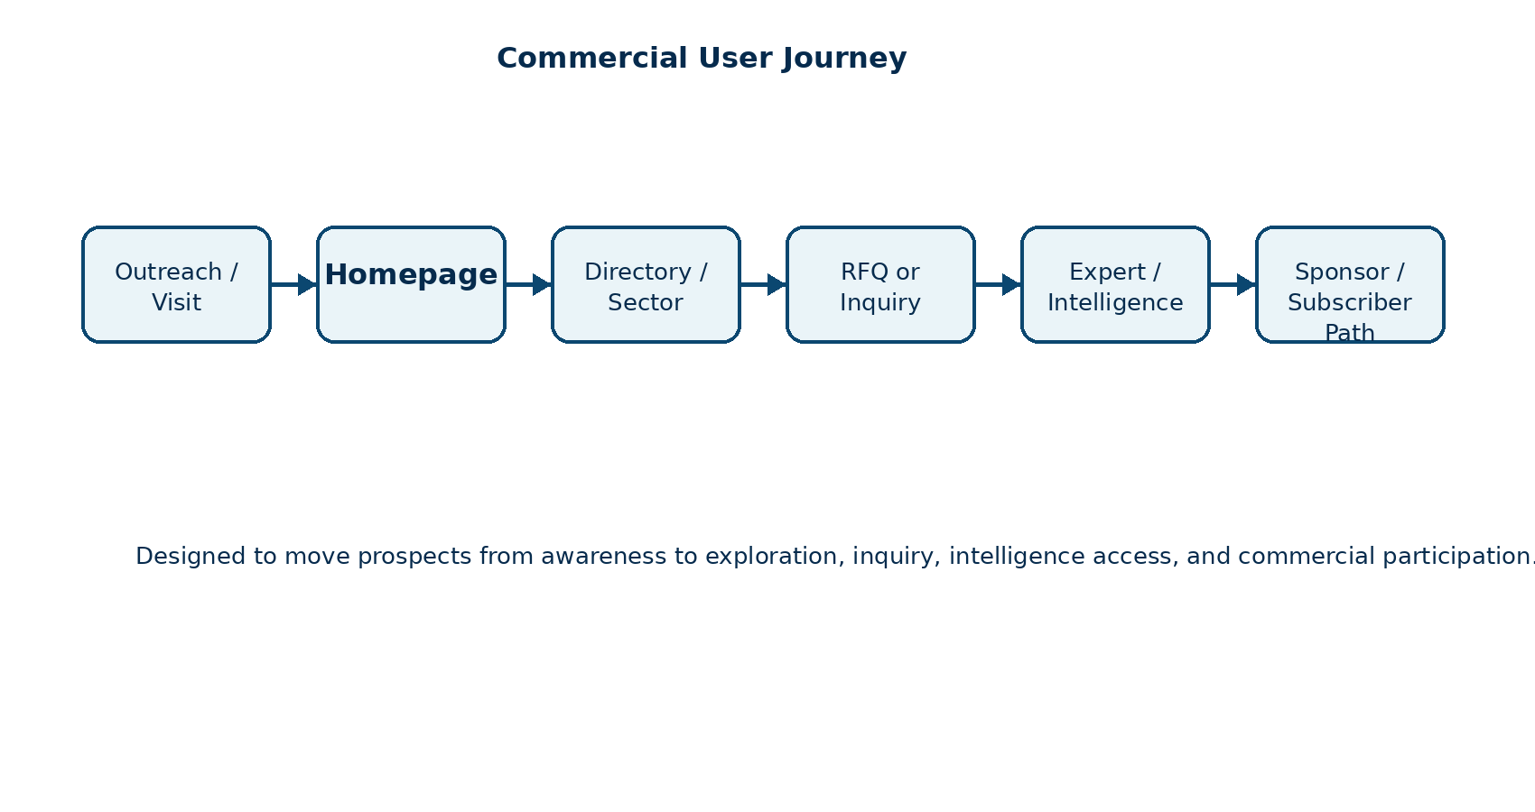

Feature Summary
Feature | Function
Industry Intelligence | Public and premium market intelligence resources for blue ammonia participants.
Directory System | Buyer, supplier and sector directories designed around commercial discovery.
RFQ Pathways | Sector-specific inquiry and RFQ workflows.
Expert Center | AI-assisted exploration of the blue ammonia ecosystem.
BAIOS | Operational command center supporting intelligence and future subscriber services.
Commercial Model | Sponsors, featured listings, premium intelligence and marketplace direction.
Network Map | Visual representation of portal structure and commercial pathways.

Founder Profile
Stevie Alston is the Founder & CEO of Blue Ammonia Holdings LLC and the creator of BlueAmmonia.com. His professional background includes many years supporting industrial, infrastructure, BIM, engineering, design, and technology-driven project environments.
As a graduate of Columbia University with a degree in Architecture, his education fostered a longstanding interest in sustainable design, resilient infrastructure, renewable energy, responsible development, and the practical role that clean energy technologies can play in shaping the built environment and global energy transition.
Blue Ammonia reflects the convergence of those interests: infrastructure, sustainability, industrial systems, commercial intelligence, and responsible technology deployment.

Frequently Asked Questions

What is Blue Ammonia?
An independent industry intelligence and commercial networking platform focused on the global blue ammonia ecosystem.

Who is it for?
Producers, buyers, technology providers, ports, shipping companies, EPC firms, investors, governments, associations and other industry participants.

Is Blue Ammonia a broker or trading platform?
No. It is currently an information, intelligence, visibility and networking platform unless expressly stated otherwise.

How do sector directories work?
Each sector can provide buyer and supplier navigation, RFQ pathways, and future premium directory access.

What is BAIOS?
The Blue Ammonia Intelligence Operating System, an operational and intelligence layer supporting the portal.

What is the Expert Center?
An AI-assisted interface designed to help users explore industry questions, intelligence and opportunities.

How can companies participate?
Through outreach, listings, sponsorships, premium intelligence, RFQs, and future subscriber services.

Contact Information
Blue Ammonia Holdings LLC
BlueAmmonia.com
Founder & CEO: Stevie Alston
Email: info@blueammonia.com
BlueAmmonia.com is permanently hosted on the exclusive exact-match BlueAmmonia.com domain.
Disclaimer: This document is an informational outreach and platform overview package. It does not constitute legal, financial, investment, engineering, regulatory or professional advice. Third-party names and references remain the property of their respective owners and do not imply endorsement, sponsorship or affiliation unless expressly stated.

Blue Ammonia at a Glance
The following summary page adds the Production V2 executive highlights recommended for corporate outreach. It is intended to support fast review by executives, commercial teams, sponsors, investors, ports, technology providers and industry participants.
20 | 40 | 8 | 1 | Global | AI
Industry Sectors | Buyer/Supplier Sector Pages | AI Expert Agents | Exact-Match Domain | Industry Focus | Enabled Platform

Investment / Strategic Highlights
Blue Ammonia combines an exact-match industry domain, a working portal, sector directories, commercial pathways, AI-assisted Expert Center capabilities, BAIOS operational dashboards and a scalable sponsorship/subscriber model.

Platform Positioning
BlueAmmonia.com is positioned as an AI-enabled industrial intelligence and commercial networking platform for the global blue ammonia ecosystem.

Commercial Relevance
The platform supports sponsor visibility, premium intelligence, RFQ intake, buyer/supplier discovery, sector organization and future subscriber services.

Section Index
- Executive Summary
- Founder Letter
- Platform Overview
- Portal Navigation Guide
- Buyer and Supplier Directories
- Industry Sector Ecosystem
- Commercial Model
- BAIOS Command Center
- AI Expert Center
- Portal Architecture
- Commercial User Journey
- Feature Summary
- Founder Profile
- FAQ
- Contact

