BLUE AMMONIA
Portal Engine User Guide
Visitor, Trial, Subscriber, Sponsor, Partner, and Operator Reference
Version 2.0 | Live Production Portal Engine | August 2026
This guide explains the current BlueAmmonia.com Portal Engine interface, account paths, intelligence functions, agents, maps, directories, commercial workflows, and operator controls.
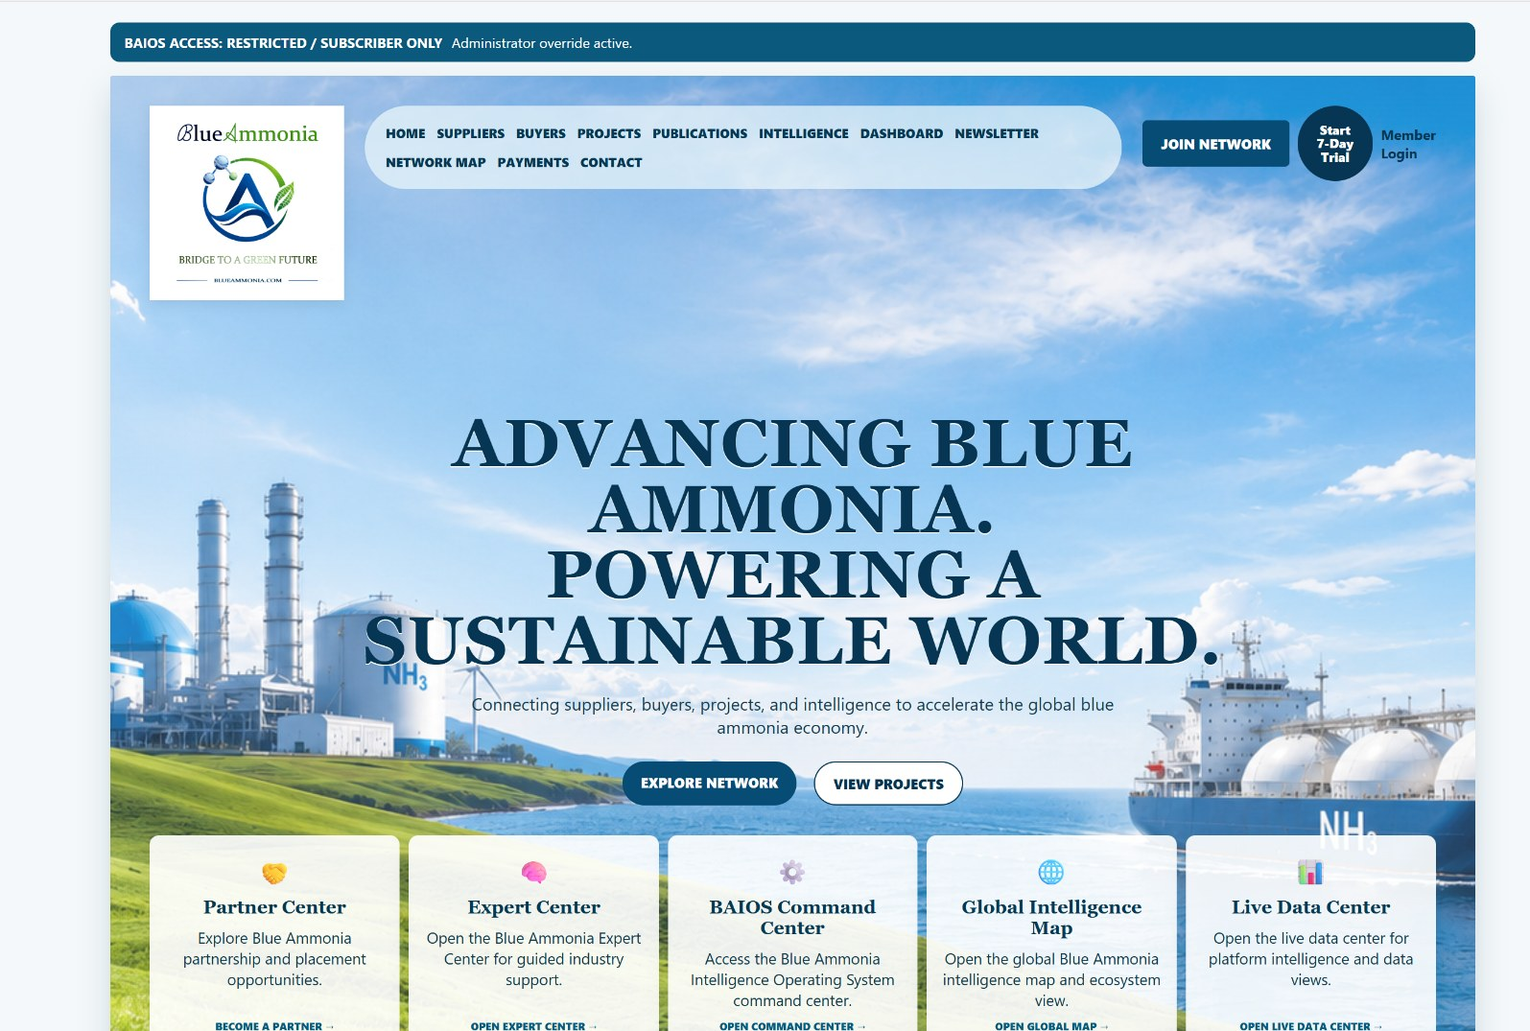
Current BlueAmmonia.com Portal Engine production interface.
Domain and platform statement
BlueAmmonia.com is the permanent exact-match home of the Blue Ammonia Intelligence Portal. The production portal is now delivered by the independent BAIOS Portal Engine through a specialized WordPress bridge. The domain is owned personally by Stevie T. Alston and licensed for use by Blue Ammonia Holdings LLC.

QUICK START
Choose the path that matches your role

Role | Start Here | Typical Next Steps
Public visitor | Front door or public homepage | Review platform purpose, request prospectus, submit inquiry, explore public pages or start a trial.
Trial user | Start 7-Day Trial | Automatic account creation -> email -> member dashboard -> permitted member areas.
Subscriber / sponsor | Member Login | Dashboard -> premium intelligence, agents, directories, map, RFQs, notifications and downloads.
Company / recruiter | Jobs, Partner Center, Payments or Contact | Submit a job, request placement, purchase a defined option or discuss an enterprise arrangement.
Operator / administrator | WordPress BAIOS Engine menu + local Setup Console | Verify health, access mode, bridge pairing, synchronization, LLM, tunnel, continuity and backups.

Important distinction
The front door and Portal Engine access mode are separate controls. A front door can be enabled while the Engine is Open or Restricted. Changing access mode does not automatically remove the front door.

1. Public Front Door
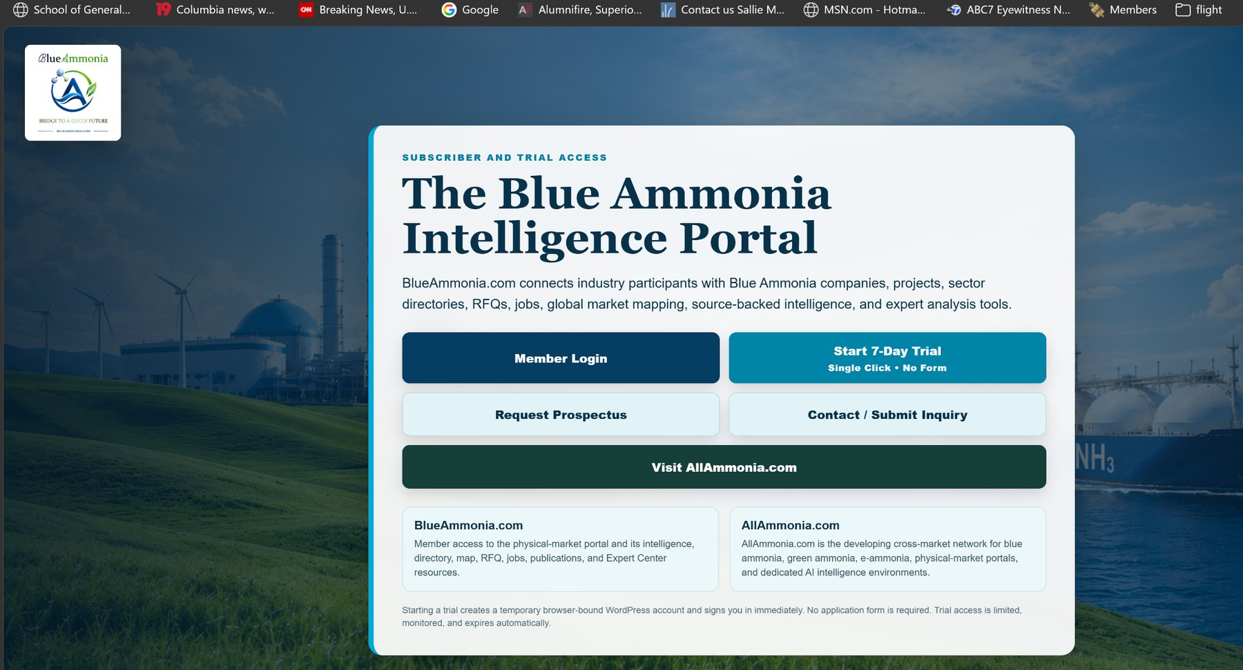
Anonymous visitor front door on BlueAmmonia.com.
- Choose Member Login when you already have a subscriber, trial, sponsor or commercial-access account.
- Choose Start 7-Day Trial for immediate trial-account creation and sign-in.
- Choose Request Prospectus to submit the controlled prospectus request form.
- Choose Contact / Submit Inquiry for general, commercial, partnership or support inquiries.
- Choose Visit AllAmmonia.com to view the developing cross-market network.
Trial notice
A one-click trial creates a temporary WordPress account linked to the browser session, signs the user in, sends account emails, applies subscriber capabilities and schedules automatic expiration. IP safety limits and monitoring reduce automated abuse.

2. Member Login and Account Recovery
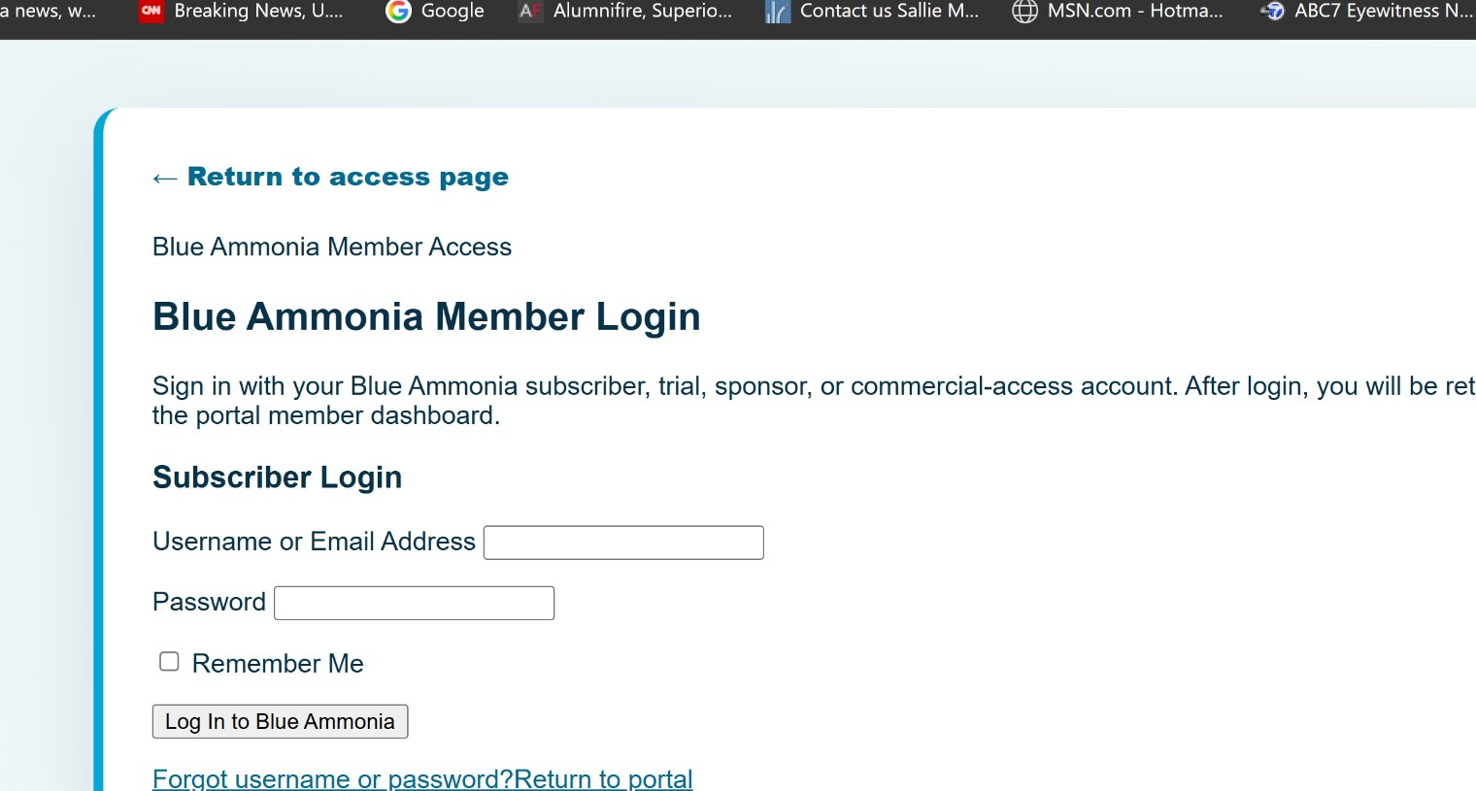
Member login and account-recovery interface.
- Enter the username or email address associated with the account.
- Enter the account password and optionally select Remember Me.
- After successful login, the user is returned to the commercial member dashboard.
- Use the account-recovery section or the standard WordPress reset link when credentials are unavailable.
- Contact support when account email, subscription status or entitlement cannot be matched.
Domain note
The production login path is on BlueAmmonia.com. The alternate bluammonia.com domain is the archived legacy plugin site and should not be used for new portal accounts.

3. Trial and Member Dashboard
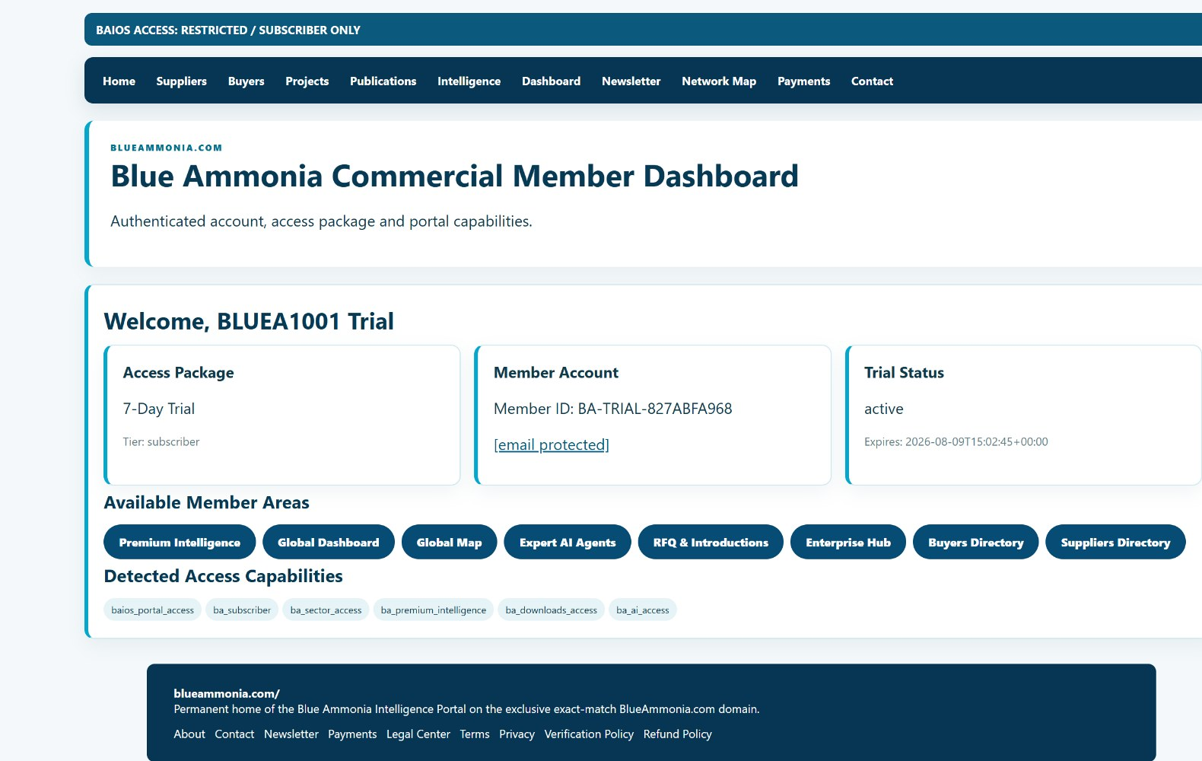
Seven-day trial dashboard with package, member identity, expiration and available capabilities.
After trial creation or member login, the dashboard shows the account package and the current access state. Available areas depend on the capabilities assigned to the account.
Dashboard Element | Meaning
Access Package | Trial, subscriber, sponsor or other configured package.
Member Account | Member ID, username and associated email.
Trial / Subscription Status | Active, expired, cancelled or other configured state and expiration.
Available Member Areas | Clickable destinations permitted for the current package.
Detected Access Capabilities | Technical entitlements such as portal, subscriber, sector, premium, download and AI access.

- Do not share browser-bound trial sessions across users.
- A trial may be limited, monitored and automatically expired.
- A paid package may require checkout completion or administrator assignment before all capabilities appear.
- Log out after testing another user's access to avoid mixing administrator override with subscriber behavior.

4. Access Modes and Front-Door Behavior
Mode | Anonymous Visitor | Authenticated Member | Administrator
Open | Public pages and configured public functions remain visible. | Member areas depend on capabilities. | Administrator override and controls remain available.
Restricted | Public homepage and approved public routes remain visible; premium components are gated. | Subscriber capabilities unlock protected areas. | Administrator override supports testing.
Front Door ON | Anonymous visitors see the acquisition/access page first. | Logged-in users may continue to the portal. | Operator can preview, configure or disable it.
Continuity Mode | Last synchronized read-only snapshot is shown when Engine connectivity is unavailable. | Live agents/forms/refreshes may be unavailable. | Operator should restore Engine/tunnel connectivity and resynchronize.

Component-level gating
Restricted mode should not erase the public homepage. The system hides or blocks protected components and actions while preserving intentionally public pages.

For anonymous testing, use an InPrivate/incognito window or a separate browser profile. Administrator sessions display an override banner and are not a reliable test of public behavior.

5. Homepage Navigation
Live production homepage and primary navigation.
Navigation Item | Purpose
Home | Return to the main platform entry point.
Suppliers / Buyers | Open separate company-side directory pathways.
Projects | Review project records and related commercial context.
Publications | Open reports, articles, guides and document resources.
Intelligence / Dashboard / Newsletter | Open intelligence routing, dashboards and publication workflows.
Network Map | Open the Global Intelligence Map.
Payments | View current commercial options and approved checkout destinations.
Contact | Open inquiry and support pathways.
Partner Center / Expert Center / BAIOS / Live Data | Use homepage action cards for high-value portal functions.
Sectors | Open the combined twenty-sector directory.

6. Noteworthy Items and the Intelligence Fabric
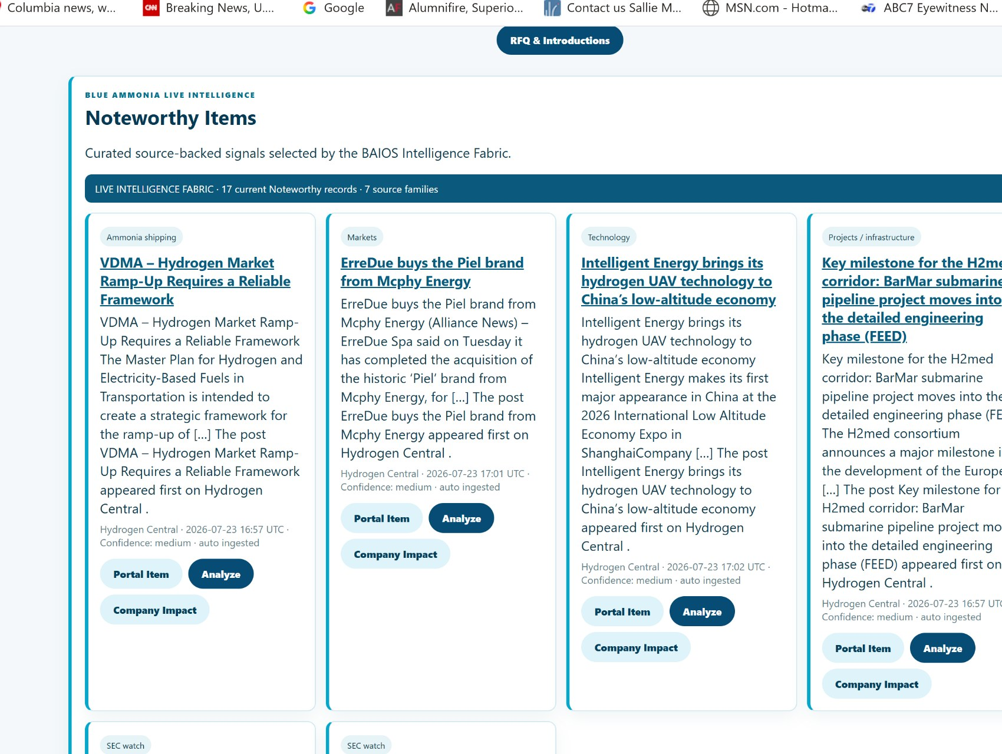
Noteworthy Items with category, title, summary, source/date/confidence metadata and agent handoff buttons.
- Read the category, title and summary.
- Review the publisher, publication date, confidence and ingestion/review state.
- Choose Portal Item to open the canonical internal record.
- Choose Analyze to load the record into the Noteworthy Analysis Agent.
- Choose Company Impact to add a company-specific question while retaining the same source record.
- Open the external source only when independent source review is required.
Interpretation rule
A Noteworthy record is a curated portal signal, not proof that the underlying claim is correct or commercially material. Use the source, date, confidence, review state and agent caveats together.

7. Expert Center and Agent Profiles
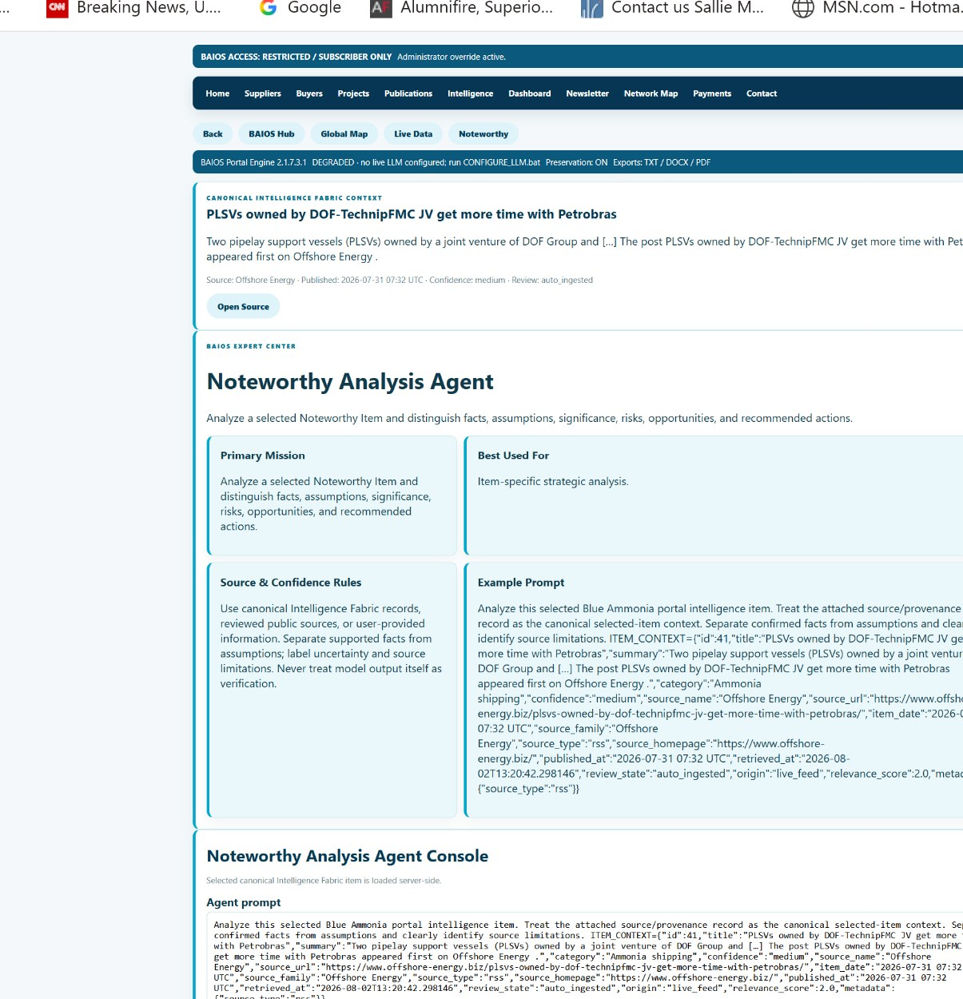
Agent profile and console with attached canonical Intelligence Fabric context.
Agent pages explain what the agent is for before the user generates a response. The primary mission, best-use field, source/confidence rules and example prompt should be reviewed before editing the prompt.
Step | Action
1. Confirm context | Verify the selected item, source and confidence information shown above the agent.
2. Read the mission | Confirm that the selected agent matches the question.
3. Edit the prompt | Add the company, geography, timeframe, decision or output format needed.
4. Generate | Submit the request to the detached Agent Execution Bridge.
5. Review | Check runtime, provider/model, confidence state and source context before relying on the output.
6. Preserve / export | Copy, download TXT/DOCX/PDF, print or return to the agent.

8. Running an Agent and Automatic Status Refresh
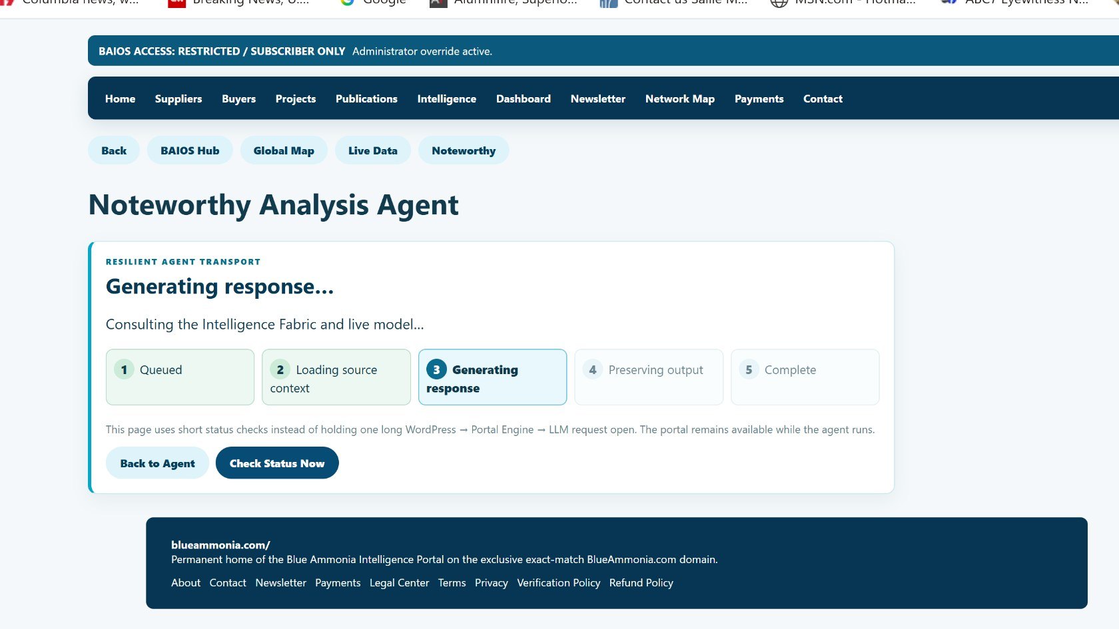
Agent generation progress page after the automatic-refresh correction.
The Portal Engine dispatches the request to an independent execution worker. The page performs short status checks instead of holding one long WordPress-to-Engine-to-LLM connection open.
Progress Stage | Meaning
Queued | Request accepted and waiting for a worker.
Loading source context | Canonical portal record and related context are being assembled.
Generating response | The configured live model or explicitly labeled fallback is producing the answer.
Preserving output | The response and metadata are being stored.
Complete | The preserved output page is ready.

- The page should advance automatically when complete.
- Use Check Status Now when the browser blocks or delays automatic polling.
- Do not submit the same prompt repeatedly while a job is still active.
- A timeout or degraded response should remain explicitly labeled.

9. Reviewing and Exporting Agent Output
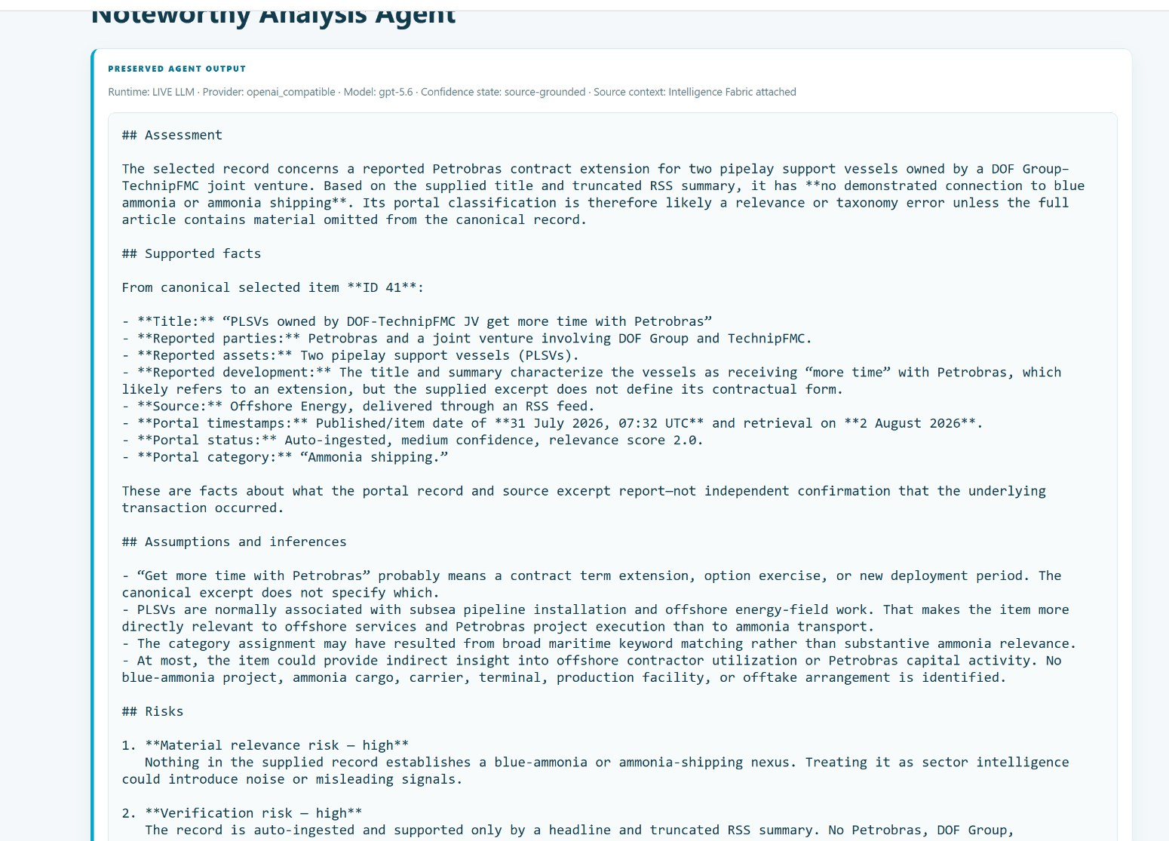
Preserved live-model output with supported facts, assumptions, risks and runtime metadata.
- Confirm that Runtime shows LIVE LLM when a live model response is expected.
- Review the provider/model and confidence state.
- Confirm that source context is attached and that the response refers to the selected record.
- Separate supported facts from assumptions and inferences.
- Treat risks and recommended actions as decision-support suggestions requiring review.
- Use Copy, Download TXT, Download Word-Compatible DOCX, Download PDF or Print / Save PDF as needed.
- Export links may expire; preserved output remains associated with Agent Memory where configured.
No silent fallback
When the configured model is unavailable, the Portal Engine is designed to produce a clearly labeled degraded/non-LLM response rather than disguising deterministic output as live AI analysis.

10. Global Intelligence Map
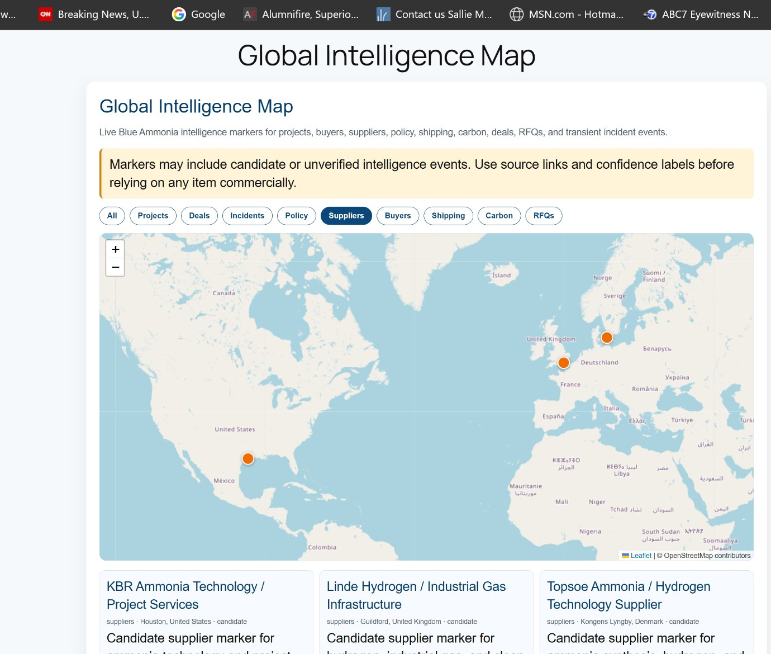
Global Intelligence Map with category filters and supplier records.
- Choose a category filter such as Projects, Deals, Incidents, Policy, Suppliers, Buyers, Shipping, Carbon or RFQs.
- Select a marker to review the location-linked record.
- Read the location-confidence language before treating a marker as an exact facility or project coordinate.
- Use the companion record cards or under-map directory for text navigation.
- Open the Map Manager Agent when classification, regulation, transport, compliance or RFQ analysis is needed.
- Open source links before making a commercial or operational decision.
Map caveat
Headquarters and country-center fallbacks are useful for discovery but are not exact project coordinates. The Portal Engine should label the authority of each location.

11. Buyers, Suppliers, Sectors, and External Referrals
Area | How to Use It
Buyers Directory | Choose a sector, review buyer-side participants and open the relevant company or source record.
Suppliers Directory | Choose a sector, review supplier-side participants and open the relevant company or source record.
Sector Directory | Use the combined twenty-sector index, then select the buyer or supplier pathway.
Company links | Tracked referral links should open the intended external company destination rather than WordPress admin or login.
Source links | Use source links to verify the basis of a listing.
Status language | Do not interpret a listing as verified, approved or an official partnership unless explicitly stated.

The sector framework includes twenty recurring categories:
- Producers, hydrogen companies, energy companies, ports, shipping, marine fuels, fertilizer and chemical manufacturing.
- EPC contractors, technology providers, equipment manufacturers, storage providers, pipeline operators, utilities, mining and steel.
- Certification organizations, financial institutions, government services and industry associations.

12. RFQ and Introduction Workflows
RFQ and introduction pathways turn directory or intelligence discovery into a controlled request. They are suitable for supplier discovery, buyer demand, project participation, technology questions, logistics needs and strategic introductions.
- Choose RFQ & Introductions from the homepage, member dashboard, map or related record.
- Provide company, role, contact information, sector, geography, need, timeline and relevant source context.
- Avoid including confidential information that is not necessary for initial review.
- Submit the request for operator review.
- Wait for Blue Ammonia to confirm whether an introduction, clarification or additional information is appropriate.
No implied representation
Submitting an RFQ does not mean Blue Ammonia represents a listed buyer or supplier, guarantees a response, verifies a counterparty or confirms a transaction.

13. Jobs Board and Job Submission
The Jobs Board provides brand-aligned employment visibility for blue ammonia, low-carbon ammonia, hydrogen, CCUS, shipping, storage, engineering, project development, intelligence and compliance roles.
Route / Function | Purpose
Jobs Board | Public or preview listing page for curated and paid jobs.
Submit Job | Front-end form for employers, companies or recruiters.
Job Pricing | Standard and featured placement options.
Review workflow | Submitted jobs remain subject to operator review before publication.
Expiration | Listings can have a configured display period and automatic expiration.
Source / employer caveat | Curated listings retain a source URL and do not imply employer endorsement.

Historical configurable defaults are $299 for a standard 30-day post and $449 for a featured 30-day post. The live price shown on the portal controls.

14. Notification Agent and Notification Center
The Notification Agent is a subscriber service for creating monitoring rules from Portal Engine signals. The Notification Center stores generated briefs and allows users to review alerts in the context of the portal rather than receiving isolated, context-free messages.
Function | Use
Rule creation | Define companies, projects, sectors, policy, shipping, prices, RFQs, keywords or event types to monitor.
Frequency | Configure immediate, daily, weekly or other supported delivery behavior.
Brief generation | Create concise source-linked briefs when matching records appear.
Notification Center | Review and search archived subscriber briefs.
Email delivery | Receive optional notifications when enabled.
Export / preservation | Store or export briefs while retaining source and confidence context.

Privacy rule
Notification functions are for subscriber service and portal operations. They are not designed for visitor-data resale or hidden third-party retargeting.

15. Payments, Subscriptions, and Commercial Options
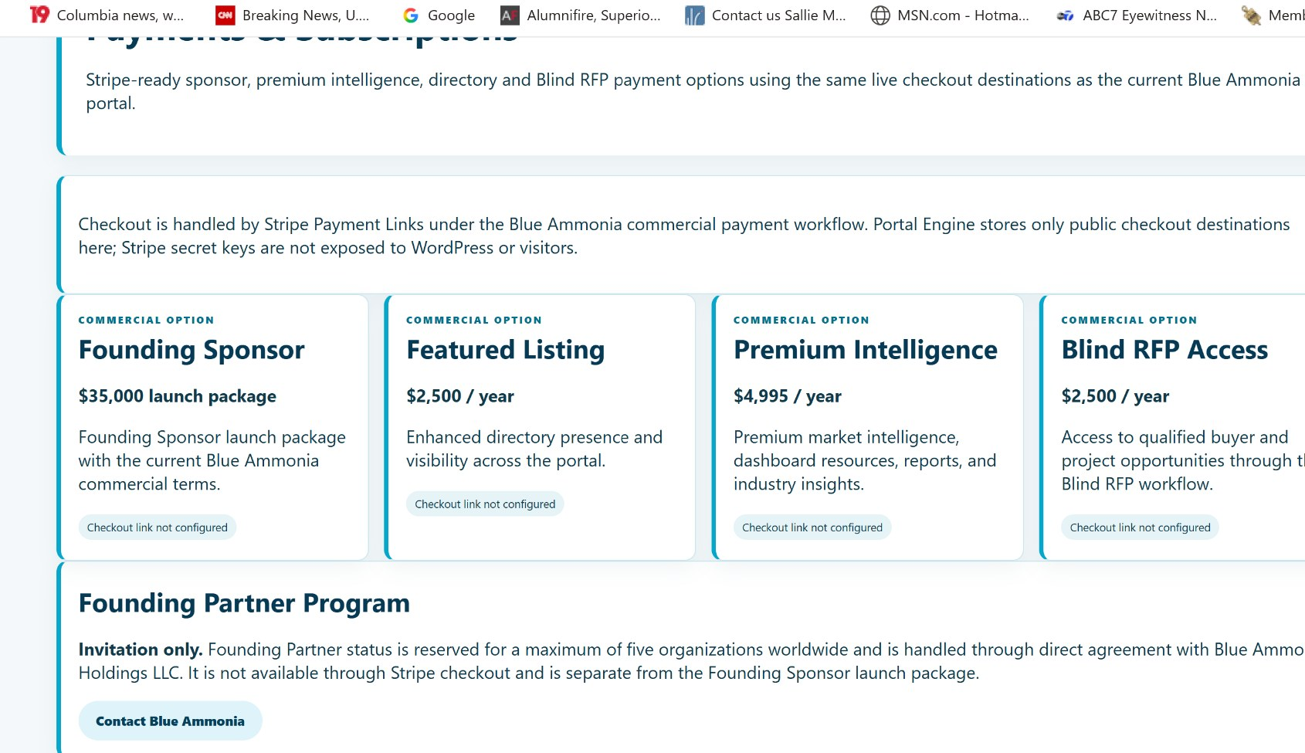
Commercial options page shown during Portal Engine staging validation.
Option | Published Structure
Founding Sponsor | $35,000 launch package.
Featured Listing | $2,500 per year.
Premium Intelligence | $4,995 per year.
Blind RFP Access | $2,500 per year.
Founding Partner | Invitation-only, maximum five organizations, direct agreement; not self-service Stripe checkout.

- Use only the checkout button presented on the current portal page.
- The Portal Engine stores approved public Stripe Payment Link destinations, not Stripe secret keys.
- A successful payment may require account matching or operator confirmation before all capabilities appear.
- Contact Blue Ammonia for invoice, contract, enterprise, sponsor or Founding Partner questions.

16. Partner Center and Visibility Areas
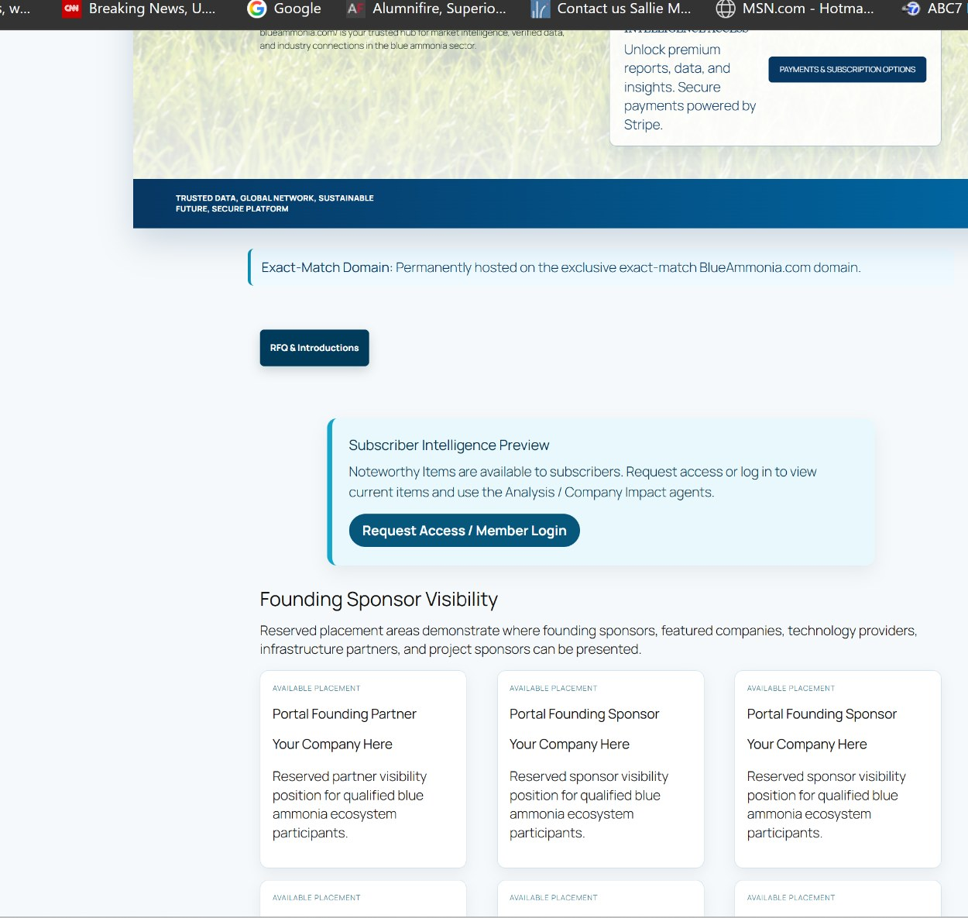
Subscriber preview, RFQ access and reserved sponsor/partner visibility areas.
The Partner Center explains how companies can participate through visibility, placement, sponsorship, project-map support, data collaboration and direct partnership discussions.
- Reserved visibility areas are available placement opportunities, not proof that a company currently occupies the position.
- Founding Sponsor and Featured Listing are distinct from the invitation-only Founding Partner program.
- Portal, sector, map, project, publication, newsletter and data sponsorships may use different terms.
- All placements remain subject to agreement, claims review and brand standards.

17. Publications, Newsletter, Live Data, and Market Intelligence
Area | Purpose
Market Intelligence Center | Organizes market signals, source review, research workflows and canonical portal records.
Live Data Center | Shows grouped feeds, source families, feed status, SEC/filing watch, policy, shipping and carbon/CCUS signals.
Publications | Provides reports, articles, user guides, prospectus access and other industry materials.
Newsletter Studio | Converts selected portal records and preserved agent outputs into reviewable drafts.
Noteworthy Items | Surfaces the highest-value current signals and routes them to analysis.
Agent Memory | Preserves outputs and context for later research or publication.

Source availability
External feeds can fail or change. Public pages should degrade gracefully, while administrators receive diagnostics. The portal should not fabricate unavailable external data.

NETWORK REFERENCE
AllAmmonia.com

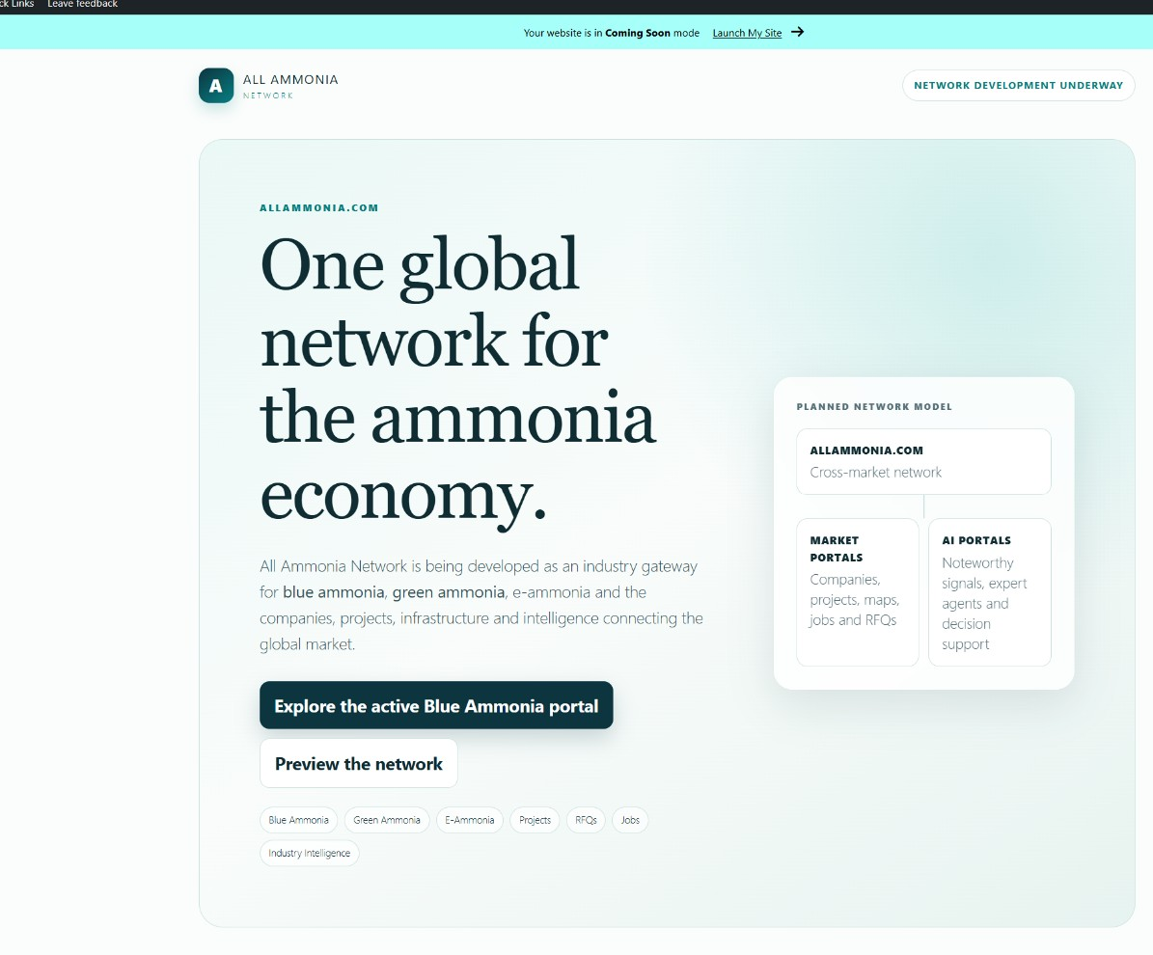
AllAmmonia.com network-development view.
AllAmmonia.com is the developing cross-market network for blue ammonia, green ammonia, e-ammonia, related physical-market portals and dedicated AI intelligence environments.
- BlueAmmonia.com remains the active specialized blue-ammonia portal.
- AllAmmonia.com provides the future umbrella and cross-market discovery concept.
- The two sites may share selected taxonomy, network navigation and platform architecture while retaining separate brands and operational states.
- A link to AllAmmonia does not mean every planned AllAmmonia feature is already live.

OPERATOR REFERENCE
Portal Engine, bridge, tunnel, access, and continuity

18. Local Setup Console
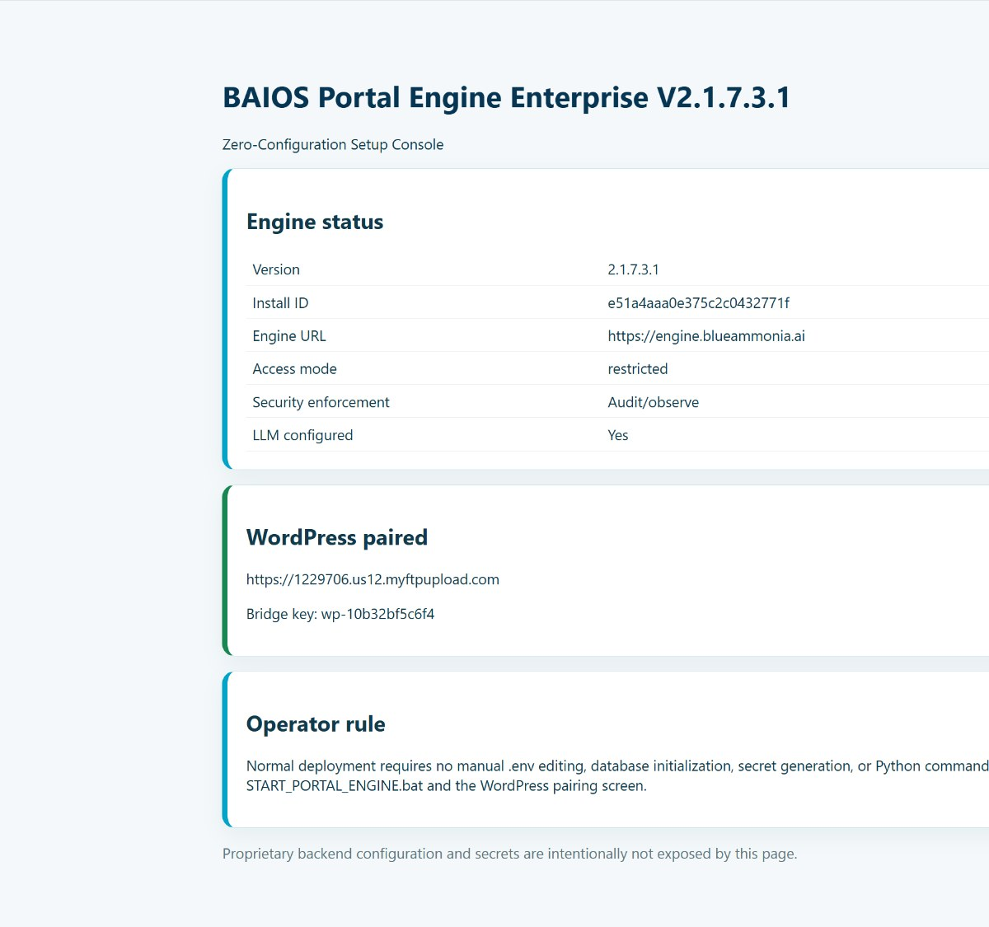
Local Portal Engine Setup Console showing version, install identity, public Engine URL, access mode, LLM status and WordPress pairing.
- Start the production Engine using the approved START_PORTAL_ENGINE batch file in the canonical build directory.
- Open the local Setup Console and confirm the expected version and install ID.
- Confirm Engine URL is the persistent production endpoint, not a temporary trycloudflare URL.
- Confirm WordPress paired is correct and LLM configured is Yes when live agents are required.
- Use /health locally and through the public Engine hostname for independent transport verification.
Root-path behavior
The Engine root may return a JSON Not Found response by design. Use /health and /setup for validation rather than treating the root response as an outage.

19. WordPress Enterprise Bridge
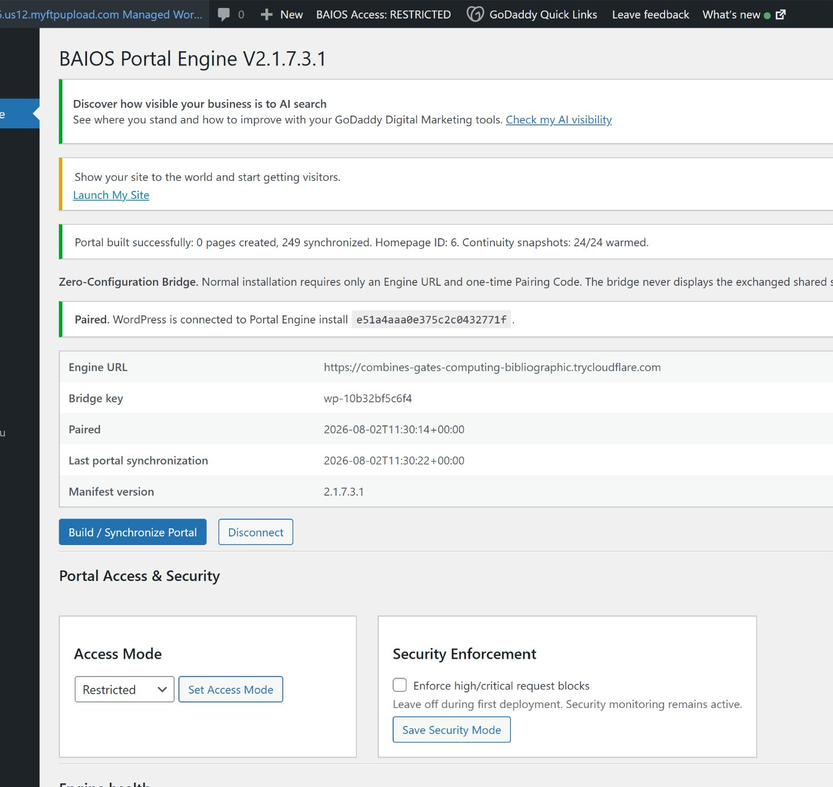
Enterprise bridge administration page with synchronization, access mode, security mode, manifest and Engine pairing.
Control | Operator Use
Engine URL / Pairing | Connect WordPress to the approved persistent Engine endpoint using the one-time pairing workflow.
Build / Synchronize Portal | Create or update synchronized portal pages and warm continuity snapshots.
Access Mode | Set Open or Restricted behavior; verify anonymously after changing.
Security Enforcement | Observe during first deployment, then enable high/critical request blocks after testing.
Engine Health | Review the current Engine status returned through the bridge.
Manifest Version | Confirm the synchronized route manifest matches the intended build.
Secret handling | Never display the exchanged shared secret, LLM API key, internal license data, recovery secrets, or proprietary source code.

20. Production and Staging Isolation
Production | Staging
Local port 8088 | Local port 8098
https://engine.blueammonia.ai | https://stage-engine.blueammonia.ai
Production WordPress / BlueAmmonia.com | Isolated staging WordPress host
Live payments and production account behavior | Payments disabled; separate trial/test behavior
Production install ID and state | Different staging install ID and mutable state
Production bridge | Staging-only bridge that rejects production endpoint and copied production identity

- Do not point the staging bridge at the production Engine.
- Do not share mutable state, payment adapters, pairing secrets or install IDs.
- Use staging for agent-refresh, front-door, access, map and feature testing before production patches.
- A cloned WordPress site may preserve pages, but staging pairing should not synchronize or modify production state.

21. Health, Continuity, and Troubleshooting
Symptom | Likely Cause / Action
Homepage shows continuity banner | Engine or tunnel unavailable. Verify local /health, public /health, cloudflared process and persistent route.
Engine root says Not Found | Expected for the root route. Test /health and /setup.
Agent remains on Queued | Wait for the worker; use Check Status Now; verify the status endpoint, bridge, browser console and LLM configuration.
Agent produces degraded output | Live provider/model unavailable or not configured. Review Setup Console and run the approved LLM configuration workflow.
Public visitor sees wrong page | Test in incognito; verify Front Door ON/OFF and Access Mode separately.
New domain routes return 404 | Resave WordPress Permalinks after domain assignment; confirm public paths and page synchronization.
External directory link opens admin/login | Verify referral-route patch/Engine route family and external destination.
Images or styles missing after cutover | Flush WordPress/GoDaddy/CDN/browser cache and rebuild/synchronize if required.
Cloudflare hostname fails | Verify published application route points to the correct local port and tunnel is Healthy.
Staging affects production | Stop immediately and verify separate port, endpoint, WordPress host, install ID and state.

22. Security, Privacy, Source, and Claims Rules
- Use only approved accounts and do not share administrator credentials.
- Do not paste LLM API keys, WordPress pairing secrets, Stripe secrets or private recovery materials into public pages or screenshots.
- Confirm sources and confidence before using portal intelligence commercially.
- Do not describe listings as verified, approved, official or partnered unless formally confirmed.
- Do not treat agent output as legal, engineering, safety, regulatory, financial or investment advice.
- Use human approval for publication, outreach, pricing, contracts, legal/regulatory claims, transactions and payment decisions.
- Report incorrect classification, broken links, stale data or misleading records through the portal inquiry/support path.
Hostile-auditor rule
When the Portal Engine, a source and an agent disagree, preserve the disagreement, identify the evidence, label uncertainty and escalate for review. Do not silently reconcile the record by inventing certainty.

23. Core Route and Function Reference
Route Family / Page | Function
/ | Front door or homepage depending on visitor/account state.
/blue-ammonia-member-access/ | Member login and account recovery.
/blue-ammonia-commercial-member-dashboard/ | Authenticated account and entitlement dashboard.
/global-map/ | Global Intelligence Map.
/agent/{slug}/ | Expert Center agent profile and console.
/agent/{slug}/job/{id}/ | Agent progress and preserved output.
/sector/{sector}/{kind}/ | Sector-specific buyer or supplier page.
/ba-go/{slug}/, /ba-sector-go/{slug}/, /r/{slug}/ | Tracked external referral route families.
Payments / subscriptions page | Commercial options and approved checkout destinations.
Jobs / submit job / job pricing | Employment listings, submissions and commercial placement.
Notification Center | Subscriber rule and brief archive.
/health | Engine health/status JSON.
/setup | Local Engine Setup Console.

Support and document status
This guide reflects the production Portal Engine baseline established during the August 2026 cutover. Portal routes, pricing, access packages and available modules may be updated through later governed builds. Use the live portal interface and current operator manifests as the final authority for active behavior.
Document baseline
BAIOS Portal Engine Enterprise V2.1.7.3.1 | persistent production tunnel | enterprise WordPress bridge | front door | one-click trial | live LLM agents | auto-refresh | Intelligence Fabric | map | directories | jobs | notifications | payments | recovery materials.

